

**SOFTWARE REQUIREMENT SPECIFICATION (SRS) SIGN-OFF**

**Authorization Memorandum**

This form is to sign-off completion of the Requirement Phase for **CAMPUS MANAGEMENT SOFTWARE AT WORLD SKILL CENTER (WSC).**

World Skill Centre (WSC) acknowledges receipt of the deliverable as part of the Requirement Phase through the submission of this document.

|  |  |
| --- | --- |
| **MODULE NAME** | **Finance and Accounting module** |

| **VERSION HISTORY** | | | |
| --- | --- | --- | --- |
| **Version** | **Author** | **Date** | **Changes** |
|  |  |  |  |
|  |  |  |  |

**WSC AUTHORITY NAME AND**  **SIGNATURE**

**SOUL AUTHORITY NAME AND**  **SIGNATURE**

Pages 1 of 97



**Sustainable Outreach And Universal**

**Leadership (SOUL) Limited**

**Software Requirement Specification (SRS)**

Of

**Finance and Accounting module**

For Implementation of

**Campus Management Software**

at

**World Skill Center (WSC)**

**Table of Content**

A. Abstract 3

B. Introduction 3

C. Definition, Acronyms and Abbreviations 3

D. Overview of the Document 3

E. Scope of Accounting Module 4

F. WSC Finance Accounting Process Flow 4

G. Process Flow Description 5

H. List of Screens and Their Descriptions 6

I. Finance and Account Home Screen 8

1. Accounting Masters 8

1.1 Company 8

1.2 Account (Chart of Accounts) 14

1.3 Fiscal Year 16

1.4 Accounting Period 18

1.5 Finance Book 20

1.6 Bank 21

1.7 Bank Account 23

1.8 Mode of payment 26

1.9 Currency 28

1.10 Party Type 30

1.11 Cost Center 31

1.12 Accounting Dimension 33

2. General Ledger and Accounting Entries 35

2.1 Journal Entry 35

2.2 GL Entry 41

2.3 General Ledger 43

2.4 Payment Entry 46

3. Bank Statement 54

3.1 Bank Reconciliation Tool 54

3.2 Bank Clearance 57

3.3 Bank Reconciliation Statement 59

4. Reports 61

4.1 Accounts Receivable 61

4.1.1 Accounts Receivable Report 61

4.1.2 Accounts Receivable Summary Report 64

4.2 Accounts Payable 67

4.2.1 Accounts Payable Report 67

4.2.2 Accounts Payable Summary Report 70

4.3 Purchase Register Report 72

4.4 Item Wise Purchase Register Report 74

4.5 Trial Balance for Party Report 76

4.6 Tax Detail Report 78

4.7 Supplier Ledger Summary Report 80

5.Financial Statements 82

5.1 Trial Balance 82

5.2 Balance Sheet 84

5.3 Profit and Loss Statement 87

5.4 Cash Flow 89

5.5 Consolidated Financial Statement 91

6. Fixed Deposit 94

# Abstract

Software Requirements Gathering is one of the first phases of system development. This phase results in the Software Requirements Specification (SRS) document, which must contain a complete, concise, high-quality description of the system being considered.

# Introduction

The World Skill Center (WSC) is a premier advanced skill training institute established by the Government of Odisha, Skill Development and Technical Education Department, through the Odisha Skill Development Authority (OSDA). The WSC will impart advanced skill training in eight trades from engineering and service sectors. WSC caters primarily to induct the best talent from ITIs and Polytechnics and train them to become globally employable in emerging areas such as "Industry 4.0". WSC is housed in a state-of-the-art, 18-storey, air-conditioned building with nearly half a million square feet of space in the heart of capital city of Bhubaneswar.

With the implementation of campus management software for WSC the goal is to streamline the operations and functions of the campus by integrating various processes, such as admissions, course registration, academic progress tracking, and financial management, HRMS, Procurement and Inventory management, etc into a unified system. The implementation also aims at providing a user-friendly interface for all stakeholders, making it easier for them to access the necessary information and complete their tasks with ease. The modules to be covered during the implementation of the software include:

|  |  |
| --- | --- |
| Students Management Modules | Infrastructure Management |
| Academic System | Finance and Accounting System |
| Procurement & Inventory Management | Training and Placement |
| Human Resources Management System | Application Integration |

# Definition, Acronyms and Abbreviations

The following table explains the terms and abbreviations used in the document:

|  |  |
| --- | --- |
| **Abbreviation** | **Description** |
| SRS | Software Requirements Specification |
| R | Rename - When a field is Renamed |
| N | New - When a New field is Added |
| D | Delete - When an Existing field is Deleted |
| NA | Not Applicable |

# Overview of the Document

This requirement document provides a detailed overview of the functional requirements of a project. It serves as a communication tool between stakeholders, including developers, project managers, and end-users. The purpose of this requirement document is to define and document the project's objectives, scope, and expectations, and to ensure that all stakeholders have a clear understanding of what the project entails.

This document covers all the functional requirements of the **Finance and Accounting module** of ERP Product. This helps in organizing the Chart of Accounts,opening Account Balances,Taxes,Advance Payments etc.

# Scope of Accounting Module

* Receipt and Payment Entries
* Direct Transfer of Caution Money to Student’s Accounts
* Demand Register
* Caution Money Register
* Bank Reconciliation Statement
* Generation of Cash Book (PL)
* Grants-in-aid Register
* Paid Voucher Register
* Advances Register
* Auditing and Tracking Pendency of Audit paras etc.

# WSC Finance Accounting Process Flow

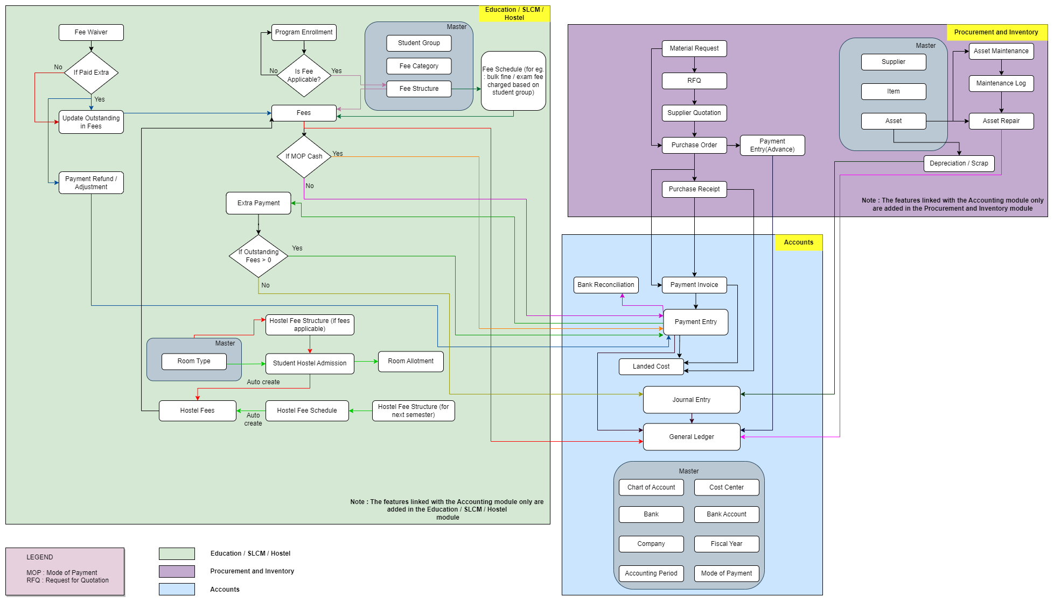

Note : The features linked with the Accounting Module are added in this flowchart

# **Process Flow Description**

**Accounts Masters**

Accounts Master represents the configuration such as Chart of Accounts, Cost center, Bank, Bank Account, Company, Fiscal Year, Accounting Period , Mode of Payment etc.

**SLCM Masters**

Student Group, Fee Category and Fee Structure are the masters which are required for the functioning of the accounts module.

**Procurement and Inventory Masters**

Supplier, Item and Asset are the masters which are essential for the accounting processes to be functional with respect to the Material Management module.

**Fee Waiver**

Fee waiver refers to an exemption or reduction of a student's fees that they would normally be required to pay in order to enroll in classes or participate in certain activities.

**Fees**

In this form, Fee Records of the students can be maintained.

**Fee Schedule**

Fee Schedule would help in defining a time-line for the Fee payment of the students, based on the Student Group.

**Payment Invoice**

A Purchase Invoice is a bill you receive from your Suppliers against which you need to make the payment.

**Payment Entry**

Payment Entry is a record indicating that payment has been made for an invoice.

Payment Entry can be made against the following transactions:

1. Purchase Invoice
2. Purchase Order (Advance Payment)
3. Expense Claim

**Bank Reconciliation**

Once all your bank transactions are imported into the application, you can reconcile them with your existing vouchers.

**Journal Entry**

A Journal Entry is an entry made in the general ledger and it indicates the affected accounts.

**General Ledger**

The General Ledger is a detailed report for all transactions posted to each account and for every transaction there is a Credit and Debit account so it lists them all up.

# **List of Screens and Their Descriptions**

|  |  |  |
| --- | --- | --- |
| **ID** | **Screen Name** | **Description** |
|  | Company | A company is a legal entity made up of an association of people carrying on a commercial or industrial enterprise. |
|  | Chart of Accounts | The Chart of Accounts is the blueprint of the accounts in your organization.Chart of Accounts is a tree view of the names of the Accounts (Ledgers and Groups) that a Company requires to manage its books of accounts.Each of the Accounts of chart of Accounts is Linked to General Ledger. |
|  | Fiscal Year | A Fiscal Year is used to record and report the transactions for the year.It is also known as a financial year or a budget year. It is used for calculating financial statements in businesses and other organizations. The Fiscal Year may or may not be the same as a calendar year. |
|  | Accounting Period | An Accounting period defines a time period in which financial statements are recorded.The selected transactions are only allowed to be created within the defined Accounting Period. |
|  | Finance Book | A Finance Book is a book against which all the accounting entries are booked. |
|  | Bank | A screen where information Bank information is stored , like Bank name,Account name details and address will be there. |
|  | Bank Account | It is a screen where Bank Accounts can be created for a Company as well as other parties like Customers, etc. Doing this lets you record all the bank transactions correctly for accounting accuracy. |
|  | Mode of Payment | The Mode of Payment stores the medium through which payments are made or received. |
|  | Currency | The Currency list stores the currency value, it's symbol and fraction unit. Most of the commonly used currencies are already present in the application. |
|  | Party Type | This can be Supplier or Student or Employee. |
|  | Cost Center | A Cost Center is a part of an organization where costs or income can be charged. |
|  | Accounting Dimension | Dimensional accounting means tagging each transaction with appropriate dimensions like Branch, Business Unit, etc. This allows you to maintain each segment separately, thereby limiting the overall maintenance on GL accounts and your Chart of Accounts remains pure. |
|  | Journal Entry | A Journal Entry is an entry made in the general ledger and it indicates the affected accounts. |
|  | General Ledger | The General Ledger is a detailed report for all transactions posted to each account and for every transaction there is a Credit and Debit account so it lists them all up. |
|  | Payment Entry | Payment Entry is a record indicating that payment has been made for an invoice. |
|  | Bank Reconciliation Tool | Once all your bank transactions are imported into the application, you can reconcile them with your existing vouchers. The final goal of Bank Reconciliation is to make the difference amount zero (green) by either matching to an existing voucher or creating a new voucher. |
|  | Bank Clearance | This feature is used to manually update clearance date with respect to payment entries which are not reconciled  You can also use this feature to update or rectify clearance date of reconciled transactions |
|  | Bank Reconciliation Statement | The Bank Reconciliation Report provides the difference between the bank balance shown in an organization's bank statement, as provided by the bank against the amount shown in the companies Chart of Accounts. |
|  | Accounts Receivable Report | This reports helps you to track the outstanding amount of Customers. It also provides ageing analysis i.e. a break-up of outstanding amount based on the period for which the amount is outstanding. |
|  | Accounts Receivable Summary Report | This reports help you to track the outstanding amount of Customers. It also provides ageing analysis i.e. a break-up of outstanding amount based on the period for which the amount is outstanding. |
|  | Accounts Payable Report | This report helps you to track the outstanding amount of Suppliers.  It also provides ageing analysis i.e. a break-up of outstanding amount based on the period for which the amount is outstanding. |
|  | Accounts Payable Summary Report | The accounts payable summary is a report that provides an overview of the money owed by the organization to its vendors or suppliers. |
|  | Purchase Register Report | This report helps you to track the outstanding amount of Suppliers with respect to the unique invoice id. |
|  | Item Wise Purchase Register Report | This report helps you to track the outstanding amount of Suppliers with respect to the individual Items. |
|  | Trial Balance for Party Report | It is common to review the trial balance for employees, students, and suppliers. This information can be easily accessed for all individuals or for specific individuals. |
|  | Tax Detail Report | Tax Details report provides an overview of all the taxes applied to transactions.This report shows the Item Tax Template, Taxes and Charges Template and Tax Category linked to various voucher types in the application. |
|  | Supplier Ledger Summary Report | This Shows the Ledger by Individual Supplier Wise |
|  | Trial Balance | A Trial Balance is an accounting report which lists account balances for all Accounts for any given reporting period. A company prepares a trial balance periodically, usually at the end of every reporting period. The general purpose of producing a trial balance is to ensure the entries in a company's bookkeeping system are mathematically correct. The totals of Debit and Credit columns must be same for any given period, to ensure the entries are correct. |
|  | Balance Sheet | A Balance Sheet is the financial statement of a company which states assets, liabilities and equity at a particular point in time.  The Balance Sheet gives more flexibility to analyse your financial position. You can run the report across multiple year to compare values. You can check values for a specific Finance Book or Cost Center. You can also choose any other currency to display the balances. |
|  | Profit and Loss Statement | A Profit and Loss Statement is a financial statement which summarizes all the revenues and expenses in a given period. The report is also known as P&L Statement. |
|  | Cash Flow | A Cash Flow is a financial statement which shows the incoming and outgoing of cash or cash-equivalents for a company. It is used to analyse the liquidity position of the company. |
|  | Consolidated Financial Statement | The report shows a consolidated view of Balance Sheet, Profit and Loss Statement and Cash Flow for a group company, by merging financial statements of all the subsidiary companies. It shows balances for all individual company and as well as accumulated balances for a group company. |

# **Finance and Account Home Screen**

This is the Homepage for the logged in User.

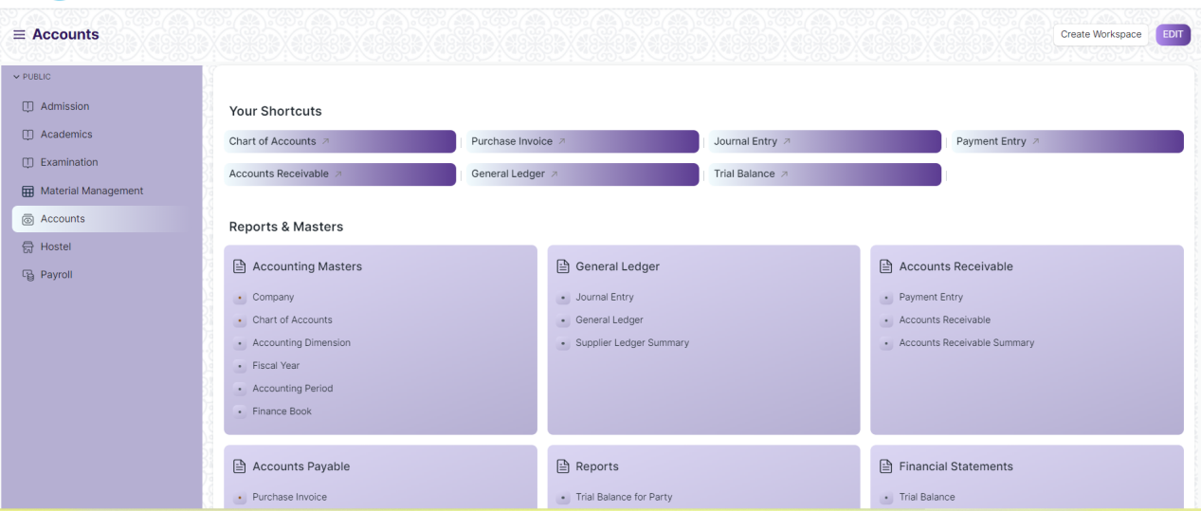

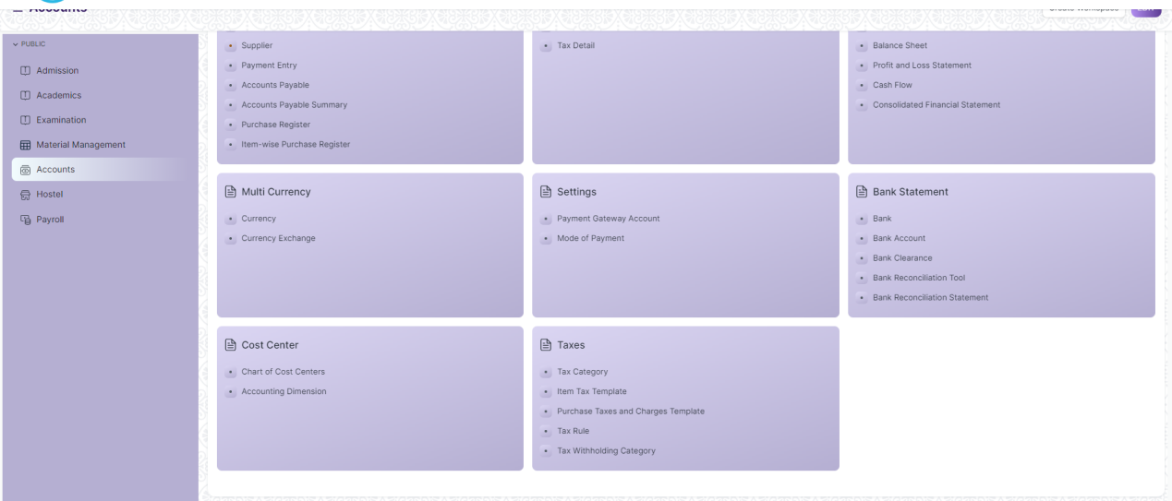

Figure: Home Screen

## Accounting Masters

### Company

**General Description:**

The following table describes overall information about this screen

|  |  |
| --- | --- |
| **Description :** | * A company is a legal entity made up of an association of people carrying on a commercial or industrial enterprise. * A parent company is a larger organization which consists of one or more child companies. A child company is a subsidiary of a parent company. * You can set up multiple companies, the company structure can be parallel, i.e., sister companies, parent-child companies, or a combination of both. |
| **Navigation :** | Home > Accounts > Accounting Masters > Company |
| **Pre-requisites :** | The system should have records in the following screen   1. Default Currency 2. Country |
| **Existing Screen Name** | Company |
| **New Screen Name** | No change |

**Screenshot:**

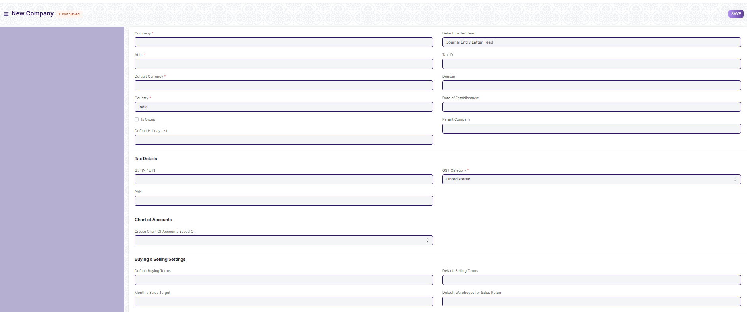

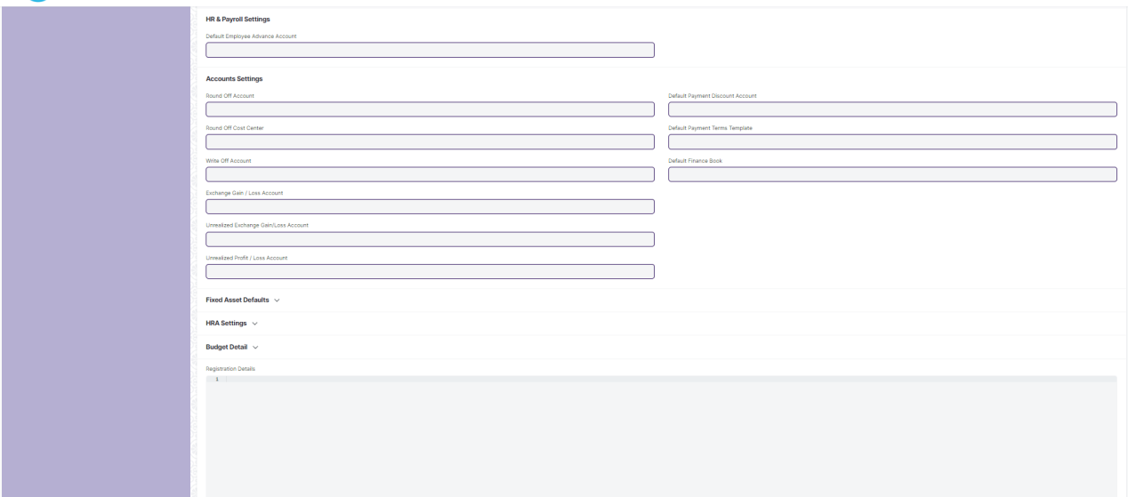

Figure: Company

**Field List:**

The following table describes the UI fields present in this screen :

|  |  |  |  |  |  |  |
| --- | --- | --- | --- | --- | --- | --- |
| **ID** | **Field Name** | **Field Type** | **Mandatory** | **Validation/Action** | **Remarks** | **R/N/D** |
|  | Abbr | Data | Yes |  |  |  |
|  | Default Currency | Link Field | Yes | Links to Currency. | Sets default currency w.r.t the company |  |
|  | Country | Link Field | Yes | Links to Country. | Sets default country w.r.t the company |  |
|  | Is Group | Checkbox | No |  |  |  |
|  | Default Holiday List | Link Field | No | Links to Holiday List. | Sets default holiday list w.r.t the company |  |
|  | Default Letter Head | Link Field | No | Links to Letter Head. | Sets default letter head w.r.t the company |  |
|  | Tax ID | Data | No |  |  |  |
|  | Domain | Data | No |  |  |  |
|  | Date of Establishment | Date | No |  |  |  |
|  | Parent Company | Link Field | No | Links to Parent Company. |  |  |
|  | Company Logo | Attach Image | No |  |  |  |
|  | Date of Incorporation | Date | No |  |  |  |
|  | Phone No | Data | No |  |  |  |
|  | Email | Data | No |  |  |  |
|  | Company Description | Text Editor | No |  |  |  |
|  | Date of Commencement | Date |  |  |  |  |
|  | Fax | Data | No |  |  |  |
|  | Website | Data | No |  |  |  |
|  | Existing Company | Link Field | No |  |  |  |
|  | Create Chart Of Accounts Based On | Dropdown | No | Options: Standard Template, Existing Company |  |  |
|  | Chart Of Accounts Template | Select | No |  |  |  |
|  | Default Buying Terms | Link Field | No | Links to buying terms. | Sets default buying terms w.r.t the company |  |
|  | Credit Limit | Currency | No |  |  |  |
|  | Transactions Annual History | Code | No | Links to Transactions Annual History. |  |  |
|  | Default Cash Account | Link Field | No | Links to Account. | Sets default cash account w.r.t the company |  |
|  | Default Receivable Account | Link Field | No | Links to Account. | Sets default Receivable account w.r.t the company |  |
|  | Round Off Account | Link Field | No | Links to Account. |  |  |
|  | Round Off Cost Center | Link Field | No | Links to Account. |  |  |
|  | Write Off Account | Link Field | No | Links to Account. |  |  |
|  | Exchange Gain / Loss Account | Link Field | No | Links to Account. |  |  |
|  | Unrealized Exchange Gain/Loss Account | Link Field | No | Links to Account. |  |  |
|  | Unrealized Profit / Loss Account | Link Field | No | Links to Account. |  |  |
|  | Allow Account Creation Against Child Company | Checkbox | No | Displays depends on if value inserted in Parent Company | If checked account will be created against child company |  |
|  | Default Payable Account | Link Field | No | Links to Account. | Sets default Payable account w.r.t the company |  |
|  | Default Income Account | Link Field | No | Links to Account. | Sets default Income account w.r.t the company |  |
|  | Default Deferred Revenue Account | Link Field | No | Links to Account. | Sets default Deferred Revenue account w.r.t the company |  |
|  | Default Deferred Expense Account | Link Field | No | Links to Account. | Sets default Expense account w.r.t the company |  |
|  | Default Payment Discount Account | Link Field | No | Links to Account. | Sets default Payment Discount account w.r.t the company |  |
|  | Default Payment Terms Template | Link Field | No | Links to Payment Terms Template. | Sets default Payment Terms Template w.r.t the company |  |
|  | Default Cost Center | Link Field | No | Links to Cost Center. | Sets default Cost Center w.r.t the company |  |
|  | Default Finance Book | Link Field | No | Links to Finance Book | Sets default Finance Book w.r.t the company |  |
|  | Enable Perpetual Inventory | Checkbox | No |  |  |  |
|  | Enable Provisional Accounting For Non Stock Items | Checkbox | No |  |  |  |
|  | Default Inventory Account | Link Field | No | Links to Inventory Account. |  |  |
|  | Stock Adjustment Account | Link Field | No | Links to Adjustment Account. |  |  |
|  | Default In-Transit Warehouse | Link Field | No | Links to In-Transit Warehouse. |  |  |
|  | Stock Received But Not Billed | Link Field | No | Links to Stock Received But Not Billed. |  |  |
|  | Default Provisional Account | Link Field | No | Links to Provisional Account. |  |  |
|  | Expenses Included In Valuation | Link Field | No |  |  |  |
|  | Accumulated Depreciation Account | Link Field | No |  |  |  |
|  | Depreciation Expense Account | Link Field | No |  |  |  |
|  | Series for Asset Depreciation Entry (Journal Entry) | Data | No |  |  |  |
|  | Expenses Included In Asset Valuation | Link Field | No |  |  |  |
|  | Gain/Loss Account on Asset Disposal | Link Field | No |  |  |  |
|  | Asset Depreciation Cost Center | Link Field | No |  |  |  |
|  | Capital Work In Progress Account | Link Field | No |  |  |  |
|  | Asset Received But Not Billed | Link Field | No |  |  |  |
|  | Exception Budget Approver Role | Link Field | No |  |  |  |
|  | Registration Details | Code | No |  |  |  |

**User: Roles & Permission**

The following table describes the users and their roles and permissions for the screens:

|  |  |  |  |  |  |  |  |  |
| --- | --- | --- | --- | --- | --- | --- | --- | --- |
| **ID** | **Role** | **Read** | **Write** | **Create** | **Delete** | **Submit** | **Cancel** | **Amend** |
| 1 | Account User | No | No | No | No | NA | NA | NA |
| 2 | Account Manager | Yes | Yes | Yes | No | NA | NA | NA |
| 3 | Accountant Admin | Yes | Yes | Yes | No | NA | NA | NA |

### Account (Chart of Accounts)

**General Description :**

The following table describe overall information about this screen

|  |  |
| --- | --- |
| **Description :** | The Chart of Accounts is the blueprint of the accounts in your organization.Chart of Accounts is a tree view of the names of the Accounts (Ledgers and Groups) that a Company requires to manage its books of accounts.Each of the Accounts of chart of Accounts is Link Fielded to General Ledger. |
| **Navigation :** | Home > Accounts > Chart of Accounts |
| **Pre-requisites :** | The system should have records in the following screen   1. Company 2. Parent Account |
| **Existing Screen Name** | Accounts |
| **New Screen Name** | No change |

**Screenshot:**

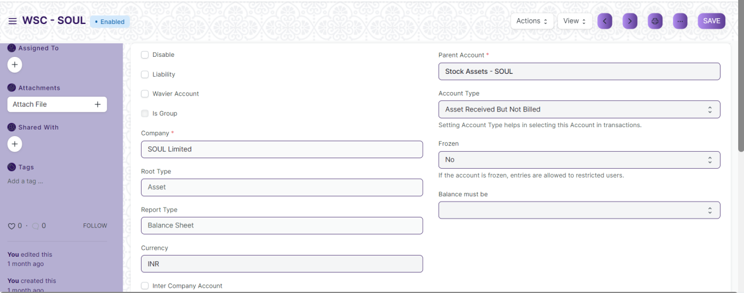

Figure: Chart of Accounts

**Field List:**

The following table describes the UI fields present in this screen:

|  |  |  |  |  |  |  |
| --- | --- | --- | --- | --- | --- | --- |
| **ID** | **Field Name** | **Field Type** | **Mandatory** | **Validation/Action** | **Remarks** | **R/N/D** |
|  | Disable | Checkbox | No | If checked account will be disabled along with the ledger |  |  |
|  | Liability | Checkbox | No | If checked account will be treated as liability |  |  |
|  | Is Group | Checkbox | No | If checked account will be treated as a group |  |  |
|  | Account Name | Data | Yes |  |  |  |
|  | Account Number | Data | No |  |  |  |
|  | Company | Link Field | Yes | Links to company | By default company will be fetched |  |
|  | Root Type | Select | No |  |  |  |
|  | Report Type | Select | No |  |  |  |
|  | Currency | Link Field | No |  |  |  |
|  | Inter Company Account | Checkbox | No |  |  |  |
|  | Parent Account | Link Field | Yes | Links to Parent Account. |  |  |
|  | Account Type | Select | No |  |  |  |
|  | Rate | Float | No |  |  |  |
|  | Frozen | Select | No |  |  |  |
|  | Balance must be | Select | No |  |  |  |

**User Roles & Permission**

The following table describes the users and their roles and permissions for the screens :

|  |  |  |  |  |  |  |  |  |
| --- | --- | --- | --- | --- | --- | --- | --- | --- |
| **ID** | **Role** | **Read** | **Write** | **Create** | **Delete** | **Submit** | **Cancel** | **Amend** |
| 1 | Account User | No | No | No | No | NA | NA | NA |
| 2 | Account Manager | Yes | Yes | Yes | No | NA | NA | NA |
| 3 | Accountant Admin | Yes | Yes | Yes | No | NA | NA | NA |

### Fiscal Year

**General Description:**

The following table describes overall information about this screen

|  |  |
| --- | --- |
| **Description :** | **A** Fiscal **Year is used to record and report the transactions for the year.**It is also known as a financial year or a budget year. It is used for calculating financial statements in businesses and other organizations. The Fiscal Year may or may not be the same as a calendar year. |
| **Navigation :** | Home > Accounts > Fiscal Year |
| **Pre-requisites :** | The system should have records in the following screen  1.Company |
| **Existing Screen Name** | Fiscal Year |
| **New Screen Name** | No change |

**Screenshots:**

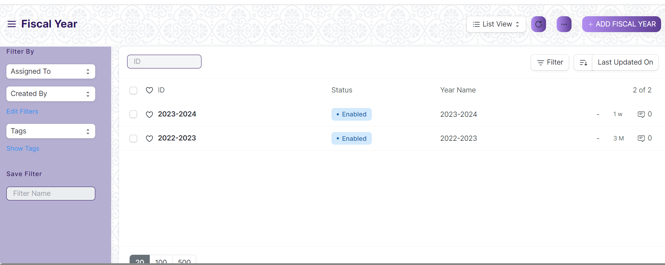

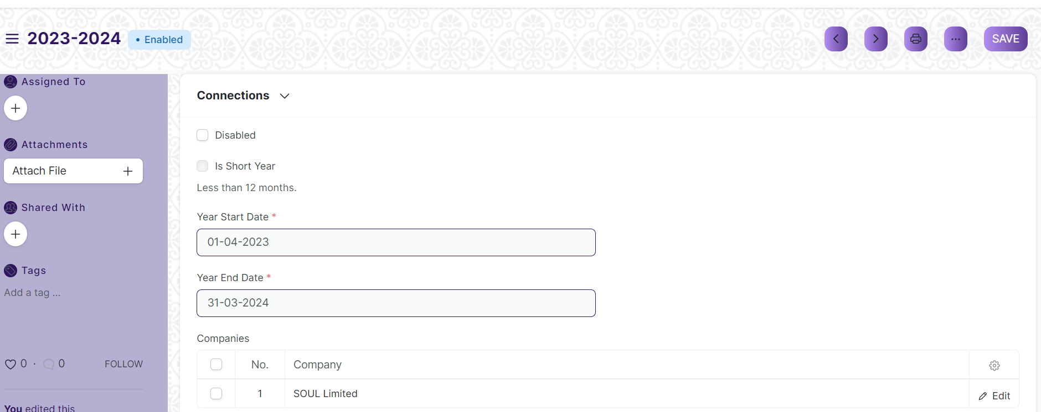

Figure: Fiscal year

**Field List:**

The following table describes the UI fields present in this screen:

|  |  |  |  |  |  |  |
| --- | --- | --- | --- | --- | --- | --- |
| **ID** | **Field Name** | **Field Type** | **Mandatory** | **Validation/Action** | **Remarks** | **R/N/D** |
|  | Disabled | Checkbox | No | If checked, fiscal year will be disabled |  |  |
|  | Is Short Year | Checkbox | No |  |  |  |
|  | Year Start Date | Date | Yes | Set the year's start date |  |  |
|  | Year End Date | Date | Yes | Set the year end date |  |  |
|  | Companies | Table | Yes |  | For further details regarding the table Please check below |  |

|  |  |  |  |  |  |  |
| --- | --- | --- | --- | --- | --- | --- |
| **Company** | | | | | | |
| **ID** | **Field Name** | **Field Type** | **Validation/Action** | **Mandatory** | **Remarks** | **R/N/D** |
| 1 | Company | Link Field |  | No | Default company will be fetched while adding rows |  |

**User: Roles & Permission**

The following table describes the users and their roles and permissions for the screens :

|  |  |  |  |  |  |  |  |  |
| --- | --- | --- | --- | --- | --- | --- | --- | --- |
| **ID** | **Role** | **Read** | **Write** | **Create** | **Delete** | **Submit** | **Cancel** | **Amend** |
| 1 | Account User | No | No | No | No | NA | NA | NA |
| 2 | Account Manager | Yes | Yes | Yes | No | NA | NA | NA |
| 3 | Accountant Admin | Yes | Yes | Yes | No | NA | NA | NA |

### Accounting Period

**General Description:**

The following table describe overall information about this screen

|  |  |
| --- | --- |
| **Description :** | **An Accounting period defines a time period in which financial statements are recorded.** Accounting Period is a time frame outside which selected submit-table transactions (like Purchase Invoice, Stock Entry, Payroll Entry, Journal Entry etc) are not allowed to be created. The selected transactions are only allowed to be created within the defined Accounting Period. |
| **Navigation :** | Home > Accounts > Accounting Period |
| **Pre-requisites :** | The system should have records in the following screen   1. Company 2. Closed Documents |
| **Existing Screen Name** | Accounting Period |
| **New Screen Name** | No change |

**Screenshots:**

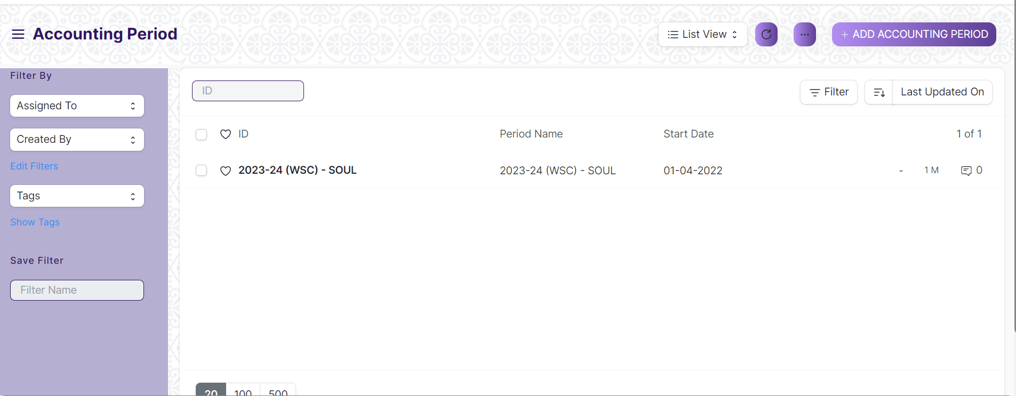

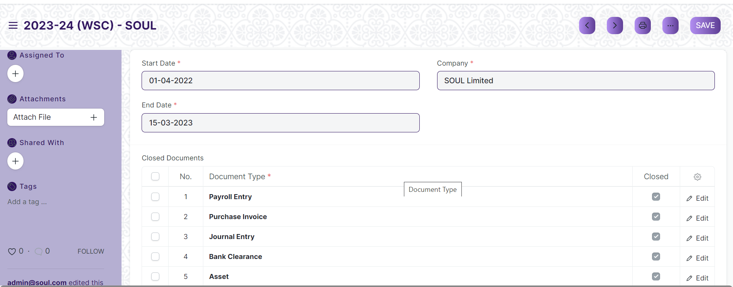

Figure: Accounting Period

**Field List:**

The following table describes the UI fields present in this screen:

|  |  |  |  |  |  |  |
| --- | --- | --- | --- | --- | --- | --- |
| **ID** | **Field Name** | **Field Type** | **Mandatory** | **Validation/Action** | **Remarks** | **R/N/D** |
| 1 | Start Date | Date | Yes | Set the period start date |  |  |
| 2 | End Date | Date | Yes | Set the period end date |  |  |
| 3 | Company | Link Field | Yes | Links to Company Screen . |  |  |
| 4 | Closed Documents | Table | Yes | For further details regarding table Please check below |  |  |

|  |  |  |  |  |  |  |
| --- | --- | --- | --- | --- | --- | --- |
| **Closed Documents** | | | | | | |
| **ID** | **Field Name** | **Field Type** | **Validation/Action** | **Mandatory** | **Remarks** | **R/N/D** |
| 1 | Document Type | Link Field | Links to doc type. | Yes |  |  |
| 2 | Closed | Checkbox |  | No | If checked the corresponding documents will be disabled which means none of the users will be able to create new entries. |  |

**User: Roles & Permission**

The following table describes the users and their roles and permissions for the screens :

|  |  |  |  |  |  |  |  |  |
| --- | --- | --- | --- | --- | --- | --- | --- | --- |
| **ID** | **Role** | **Read** | **Write** | **Create** | **Delete** | **Submit** | **Cancel** | **Amend** |
| 1 | Account User | No | No | No | No | NA | NA | NA |
| 2 | Account Manager | Yes | Yes | Yes | No | NA | NA | NA |
| 3 | Accountant Admin | Yes | Yes | Yes | No | NA | NA | NA |

### Finance Book

**General Description:**

The following table describe overall information about this screen .

|  |  |
| --- | --- |
| **Description :** | **A Finance Book is a**book**against which all the accounting entries are booked.** |
| **Navigation :** | Home > Accounts > Finance Book |
| **Pre-requisites :** | No Pre-requisite. |
| **Existing Screen Name** | Finance Book |
| **New Screen Name** | No change |

**Screenshots:**

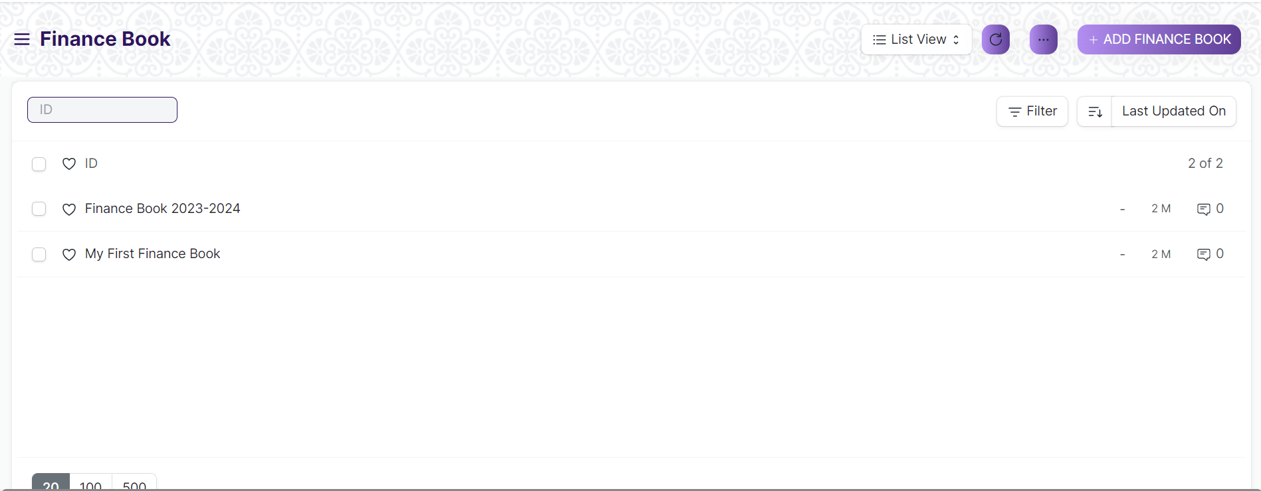

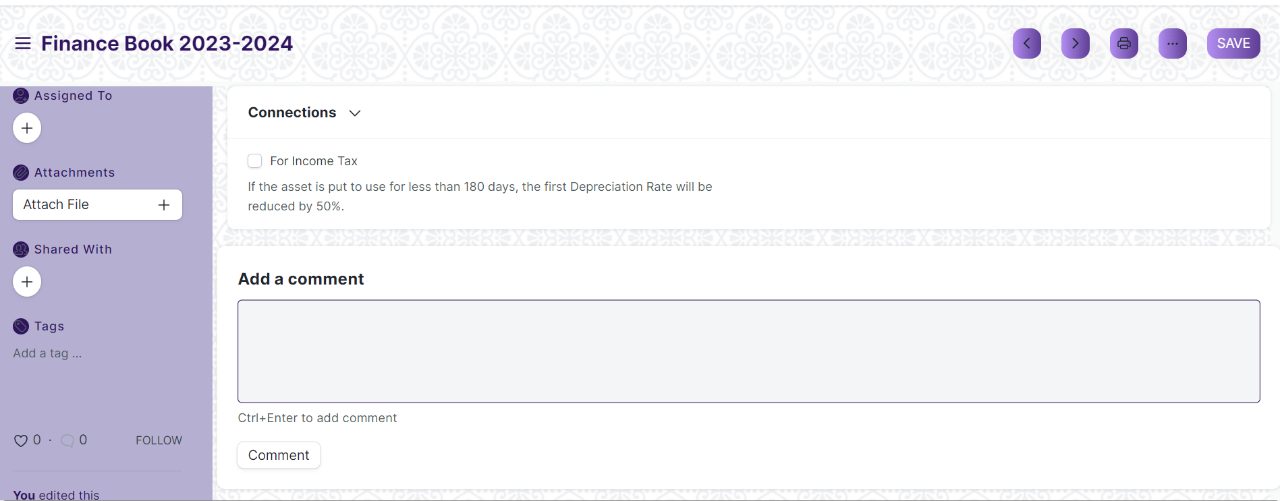

Figure: Finance Book

**Field List:**

The following table describes the UI fields present in this screen:

|  |  |  |  |  |  |  |
| --- | --- | --- | --- | --- | --- | --- |
| **ID** | **Field Name** | **Field Type** | **Mandatory** | **Validation/Action** | **Remarks** | **R/N/D** |
| 1 | Name | Data | No |  |  |  |

**User: Roles & Permission**

The following table describes the users and their roles and permissions for the screens :

|  |  |  |  |  |  |  |  |  |
| --- | --- | --- | --- | --- | --- | --- | --- | --- |
| **ID** | **Role** | **Read** | **Write** | **Create** | **Delete** | **Submit** | **Cancel** | **Amend** |
| 1 | Account User | No | No | No | No | NA | NA | NA |
| 2 | Account Manager | Yes | Yes | Yes | No | NA | NA | NA |
| 3 | Accountant Admin | Yes | Yes | Yes | No | NA | NA | NA |

### Bank

**General Description:**

The following table describe overall information about this screen

|  |  |
| --- | --- |
| **Description :** | A screen where information Bank information is stored , like Bank name,Account name details and address will be there. |
| **Navigation :** | Home > Accounts > Bank Statement > Bank |
| **Pre-requisites :** | No Pre-requisite. |
| **Existing Screen Name** | Bank |
| **New Screen Name** | No change |

**Screenshots:**

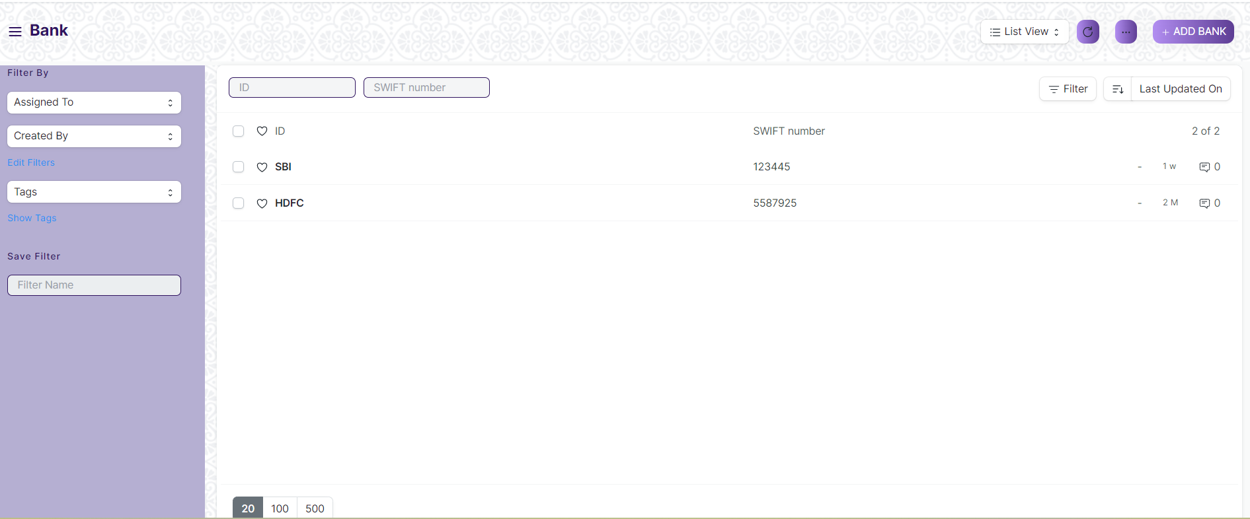

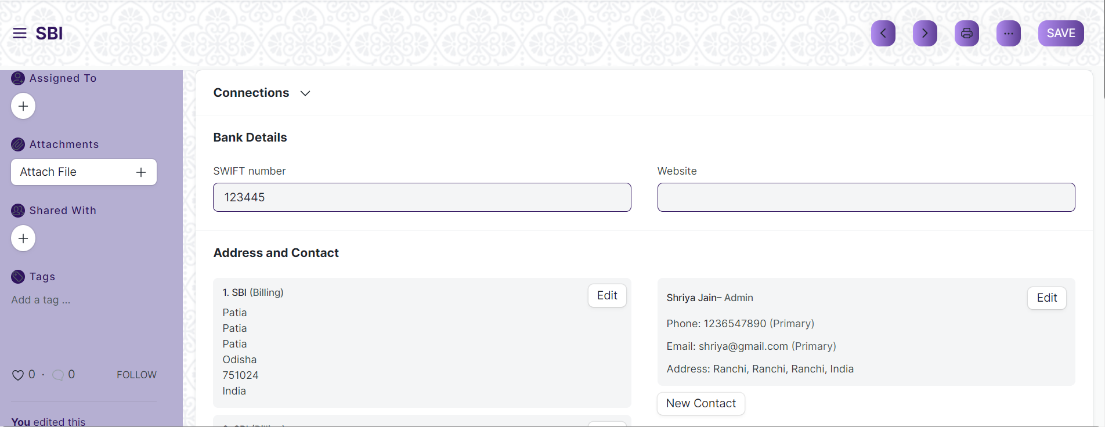

Figure: Bank

**Field List:**

The following table describes the UI fields present in this screen:

|  |  |  |  |  |  |  |
| --- | --- | --- | --- | --- | --- | --- |
| **ID** | **Field Name** | **Field Type** | **Mandatory** | **Validation/Action** | **Remarks** | **R/N/D** |
|  | SWIFT number | Data | No |  |  |  |
|  | Website | Data | No |  |  |  |
|  | Address HTML | HTML | No |  |  |  |
|  | Contact HTML | HTML | No |  |  |  |
|  | Bank Transaction Mapping | Table | No | For further details regarding table Please check below |  |  |
|  | Paid Access Token | Data | No |  |  |  |

|  |  |  |  |  |  |  |
| --- | --- | --- | --- | --- | --- | --- |
| **Bank Transaction Mapping** | | | | | | |
| **ID** | **Field Name** | **Field Type** | **Mandatory** | **Validation/Action** | **Remarks** | **R/N/D** |
| 1 | Field in Bank Transaction | Select | Yes |  |  |  |
| 2 | Column in Bank File | Data | Yes |  |  |  |

**User: Roles & Permission**

The following table describes the users and their roles and permissions for the screens :

|  |  |  |  |  |  |  |  |  |
| --- | --- | --- | --- | --- | --- | --- | --- | --- |
| **ID** | **Role** | **Read** | **Write** | **Create** | **Delete** | **Submit** | **Cancel** | **Amend** |
| 1 | Account User | No | No | No | No | NA | NA | NA |
| 2 | Account Manager | Yes | Yes | Yes | No | NA | NA | NA |
| 3 | Accountant Admin | Yes | Yes | Yes | No | NA | NA | NA |

### Bank Account

**General Description:**

The following table describes overall information about this screen

|  |  |
| --- | --- |
| **Description :** | It is a screen where Bank Accounts can be created for a Company as well as other parties like Suppliers, Employee etc. Doing this lets you record all the bank transactions correctly for accounting accuracy. |
| **Navigation :** | Home > Accounts > Bank Statement > Bank Account |
| **Pre-requisites** : | The system should have records on the following screen   1. Bank 2. Account Name |
| **Existing Screen Name** | Bank Account |
| **New Screen Name** | No Change |

**Screenshots:**

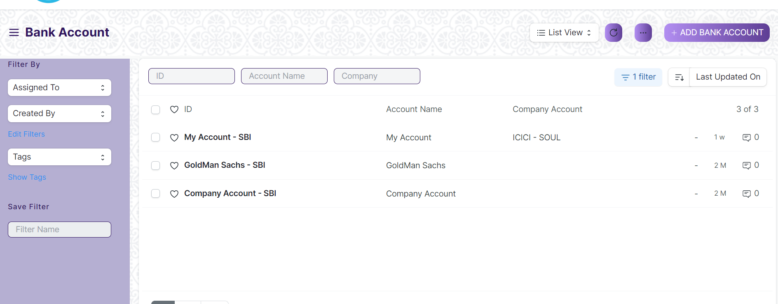

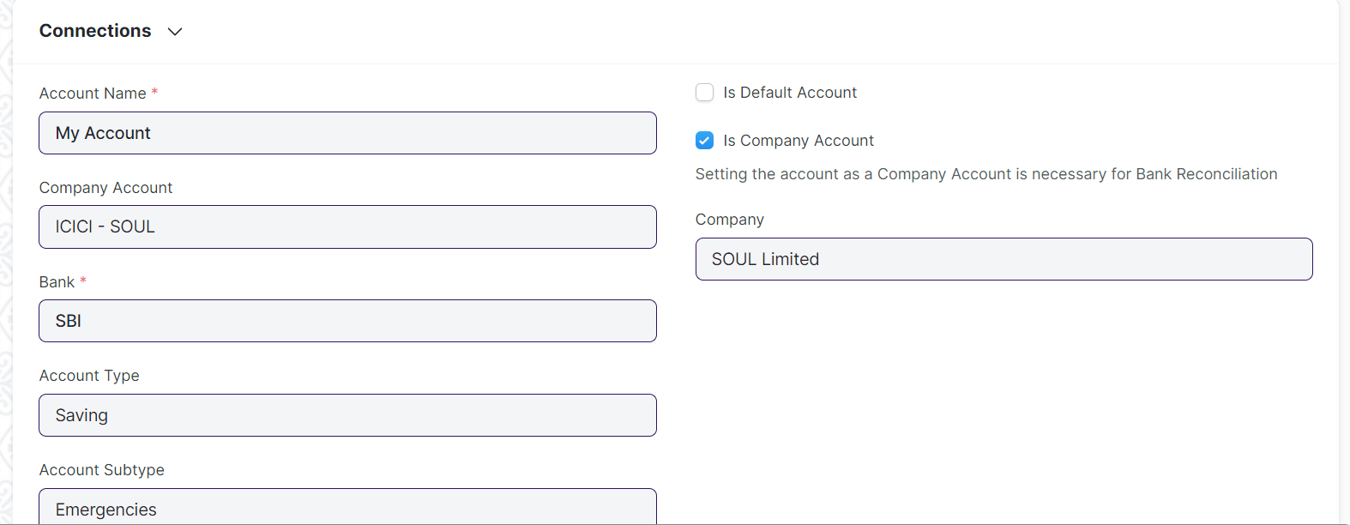

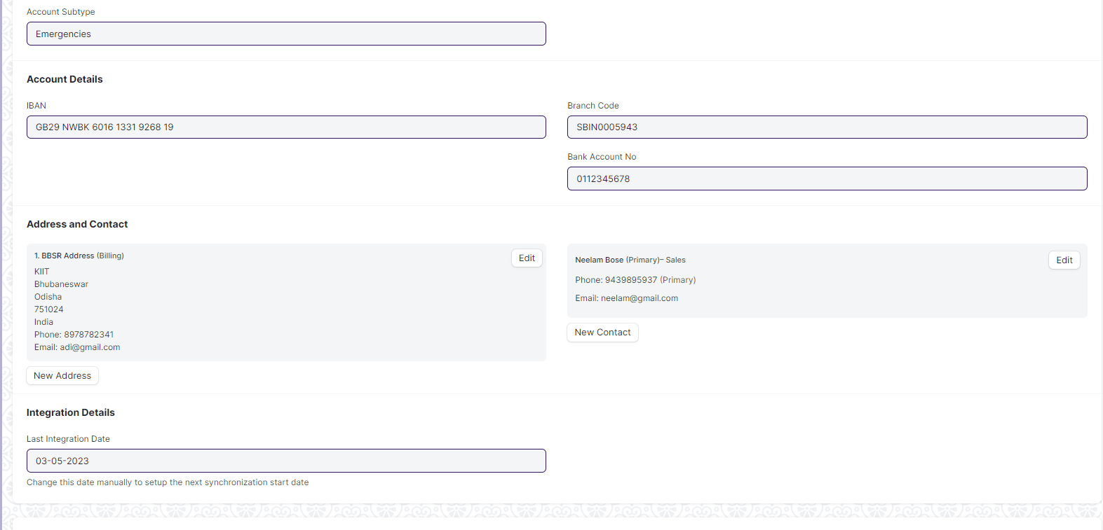

Figure: Bank Account

**Field List:**

The following table describes the UI fields present in this screen:

|  |  |  |  |  |  |  |
| --- | --- | --- | --- | --- | --- | --- |
| **ID** | **Field Name** | **Field Type** | **Mandatory** | **Validation/Action** | **Remarks** | **R/N/D** |
| 1 | Account Name | Data | Yes |  |  |  |
| 2 | Company Account | Link Field | No | Links to Company |  |  |
| 3 | Bank | Link Field | Yes |  |  |  |
| 4 | Account Type | Link Field | No | Links to Account Type Screen |  |  |
| 5 | Account Sub Type | Link Field | No | Links to Account Sub Type. |  |  |
| 6 | Is Default Account | Checkbox | No |  | If checked will set the account as default |  |
| 7 | Is Company Account | Checkbox | No |  |  |  |
| 8 | Company | Link Field | No | Links to Company screen. |  |  |
| 9 | Party Type | Link Field | No | Links to Party Type screen. |  |  |
| 10 | Party | Dynamic Link Field | No | Links to Party screen. |  |  |
| 11 | IBAN | Data | No |  |  |  |
| 12 | Branch Code | Data | No |  |  |  |
| 13 | Bank Account No | Data | No |  |  |  |
| 14 | Address | HTML | No |  |  |  |
| 15 | Contact | HTML | No |  |  |  |
| 16 | Integration ID | Data | No |  |  |  |
| 17 | Last Integration Date | Date | No |  |  |  |
| 18 | Mask | Data | No |  |  |  |

**User: Roles & Permission**

The following table describes the users and their roles and permissions for the screens :

|  |  |  |  |  |  |  |  |  |
| --- | --- | --- | --- | --- | --- | --- | --- | --- |
| **ID** | **Role** | **Read** | **Write** | **Create** | **Delete** | **Submit** | **Cancel** | **Amend** |
| 1 | Account User | No | No | No | No | NA | NA | NA |
| 2 | Account Manager | Yes | Yes | Yes | No | NA | NA | NA |
| 3 | Accountant Admin | Yes | Yes | Yes | No | NA | NA | NA |

### Mode of payment

**General Description:**

The following table describes overall information about this screen

|  |  |
| --- | --- |
| **Description :** | In purchase transactions, there are various options to settle the payment. We can do it in cash, via bank transfer, via promotion voucher to list a few. In the application, you can create Mode of Payments as per your requirement. In the Payment Entry, you can select the Mode of Payment applicable. |
| **Navigation :** | Home > Accounts > Settings > Mode of payment |
| **Pre-requisites** : | The system should have records on the following screen   1. Account |
| **Existing Screen Name** | Mode of payment |
| **New Screen Name** | No Change |

**Screenshots:**

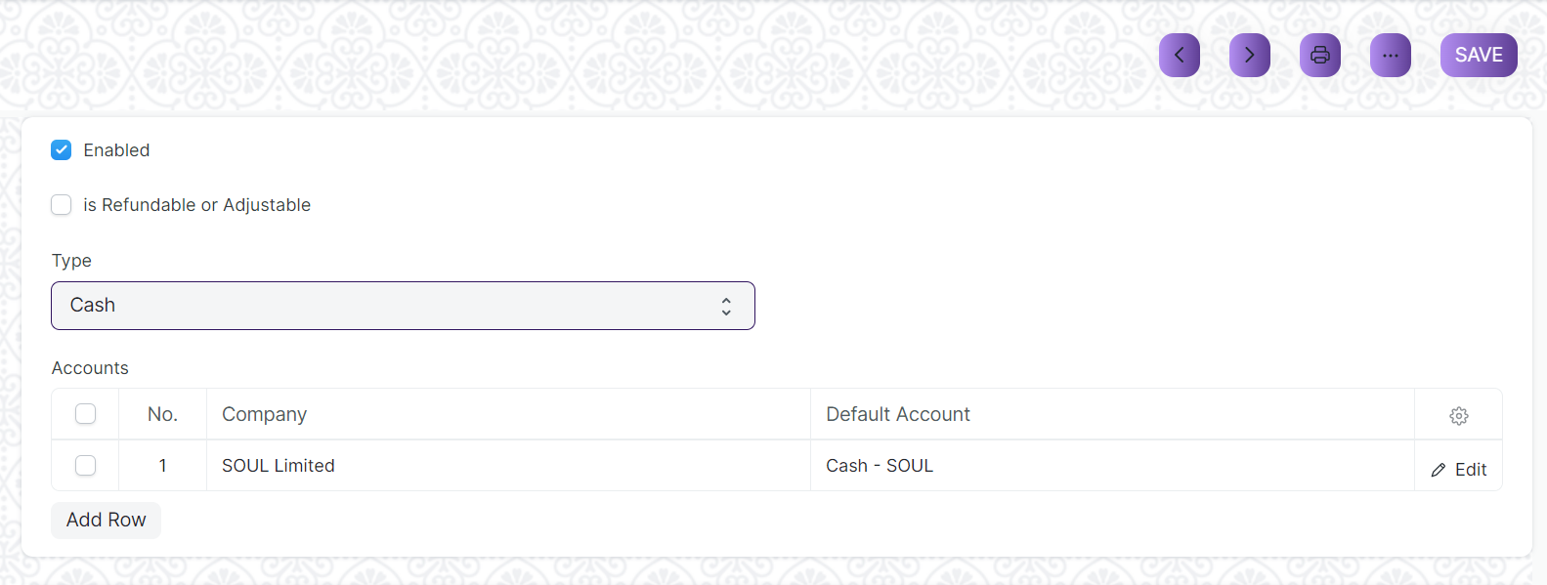

Figure: Mode of payment

**Field List:**

The following table describes the UI fields present in this screen:

|  |  |  |  |  |  |  |
| --- | --- | --- | --- | --- | --- | --- |
| **ID** | **Field Name** | **Field Type** | **Mandatory** | **Validation/Action** | **Remarks** | **R/N/D** |
| 1 | Mode of Payment | Data | Yes |  |  |  |
| 2 | Enable | Check | No | If checked then Mode of payment will be enabled. |  |  |
| 3 | is Refundable or Adjustable | Check | No | If checked then Mode of payment will be refundable or adjustable. |  |  |
| 4 | Type | Select | No |  | There are different types of Mode of Payment such as  -Cash  -Bank  -General  -Phone |  |
| 5 | Mode of Payment Account | Table | Yes |  | The description of the table is given below. |  |

|  |  |  |  |  |  |  |
| --- | --- | --- | --- | --- | --- | --- |
| **Mode of payment Account** | | | | | | |
| **ID** | **Field Name** | **Field Type** | **Validation/Action** | **Mandatory** | **Remarks** | **R/N/D** |
| 1 | Company | Link Field |  | No | Default company will be fetched while adding rows |  |
| 2 | Default Account | Link Field |  | No |  |  |

**User: Roles & Permission**

The following table describes the users and their roles and permissions for the screens :

|  |  |  |  |  |  |  |  |  |
| --- | --- | --- | --- | --- | --- | --- | --- | --- |
| **ID** | **Role** | **Read** | **Write** | **Create** | **Delete** | **Submit** | **Cancel** | **Amend** |
| 1 | Account User | No | No | No | No | NA | NA | NA |
| 2 | Account Manager | Yes | Yes | Yes | No | NA | NA | NA |
| 3 | Accountant Admin | Yes | Yes | Yes | No | NA | NA | NA |

### Currency

**General Description:**

The following table describes overall information about this screen

|  |  |
| --- | --- |
| **Description :** | The Currency list stores the currency value, it's symbol and fraction unit. Most of the commonly used currencies are already present in the application. |
| **Navigation :** | Home > Accounts > Multi Currency > Currency |
| **Pre-requisites** : | None |
| **Existing Screen Name** | Currency |
| **New Screen Name** | No Change |

**Screenshots:**

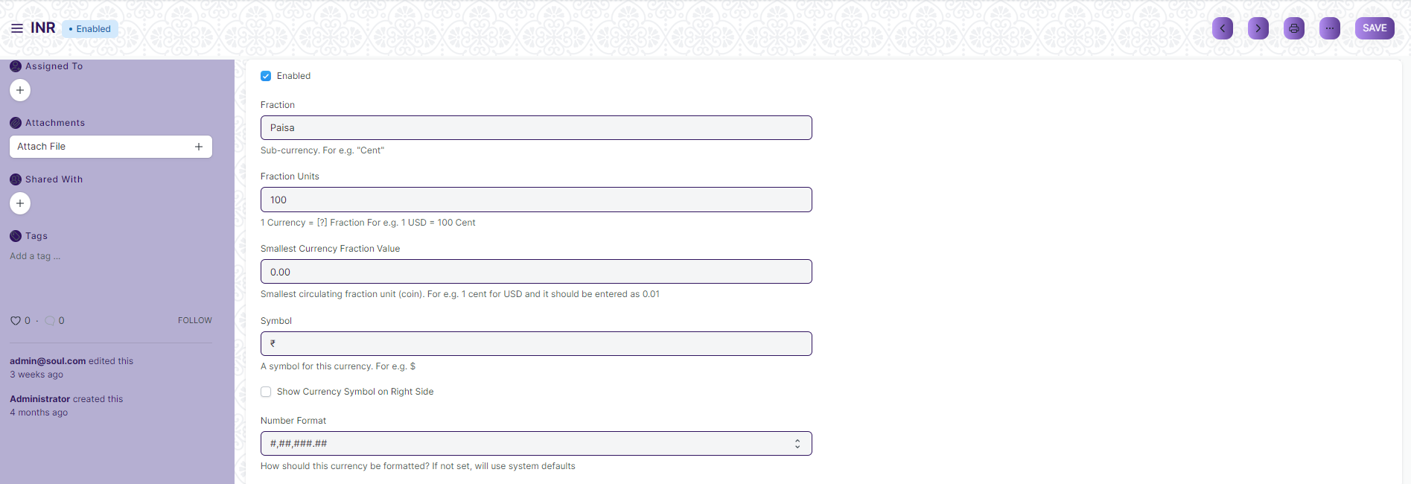

Figure: Currency

**Field List:**

The following table describes the UI fields present in this screen:

|  |  |  |  |  |  |  |
| --- | --- | --- | --- | --- | --- | --- |
| **ID** | **Field Name** | **Field Type** | **Mandatory** | **Validation/Action** | **Remarks** | **R/N/D** |
| 1 | Currency Name | Data | Yes |  |  |  |
| 2 | Enabled | Check | No |  |  |  |
| 3 | Fraction | Data | No |  |  |  |
| 4 | Fraction Units | Number | No |  |  |  |
| 5 | Smallest Currency Fraction Value | Currency | No |  |  |  |
|  | Symbol | Data | No |  |  |  |
|  | Show Currency Symbol on Right Side | Check | No | Currency Symbol will appear to the left of the amount by default if not checked | This will determine where the currency side will appear beside the amount |  |
|  | Number Format | Select | No |  | How should this currency be formatted? If not set, will use system defaults |  |

**User: Roles & Permission**

The following table describes the users and their roles and permissions for the screens :

|  |  |  |  |  |  |  |  |  |
| --- | --- | --- | --- | --- | --- | --- | --- | --- |
| **ID** | **Role** | **Read** | **Write** | **Create** | **Delete** | **Submit** | **Cancel** | **Amend** |
| 1 | Account User | No | No | No | No | NA | NA | NA |
| 2 | Account Manager | No | No | No | No | NA | NA | NA |
| 3 | Accountant Admin | No | No | No | No | NA | NA | NA |

### Party Type

**General Description:**

The following table describes overall information about this screen

|  |  |
| --- | --- |
| **Description :** | This can be Supplier or Student or Employee. |
| **Navigation :** | NA |
| **Pre-requisites** : | None |
| **Existing Screen Name** | Party Type |
| **New Screen Name** | No Change |

**Screenshots:**



Figure: Party Type

**Field List:**

The following table describes the UI fields present in this screen:

|  |  |  |  |  |  |  |
| --- | --- | --- | --- | --- | --- | --- |
| **ID** | **Field Name** | **Field Type** | **Mandatory** | **Validation/Action** | **Remarks** | **R/N/D** |
| 1 | Party Type | Link Field | Yes | This field links to DocType |  |  |
| 2 | Account Type | Select | Yes | This field have options: Payable and Receivable |  |  |

**User: Roles & Permission**

The following table describes the users and their roles and permissions for the screens :

|  |  |  |  |  |  |  |  |  |
| --- | --- | --- | --- | --- | --- | --- | --- | --- |
| **ID** | **Role** | **Read** | **Write** | **Create** | **Delete** | **Submit** | **Cancel** | **Amend** |
| 1 | Account User | No | No | No | No | NA | NA | NA |
| 2 | Account Manager | No | No | No | No | NA | NA | NA |
| 3 | Accountant Admin | No | No | No | No | NA | NA | NA |

### Cost Center

**General Description**

The following table describes overall information about this screen:

|  |  |  |
| --- | --- | --- |
| **Description** | | A Cost Center is a part of an organization where costs or income can be charged. |
| **Navigation** | Home > Accounts > Cost Center > Chart of Cost Centers | |
| **Pre-requisites** | The system should have records on the following screen   1. Company | |
| **Existing Screen Name** | Cost Center | |
| **New Screen Name** | No change | |

**Screenshot**

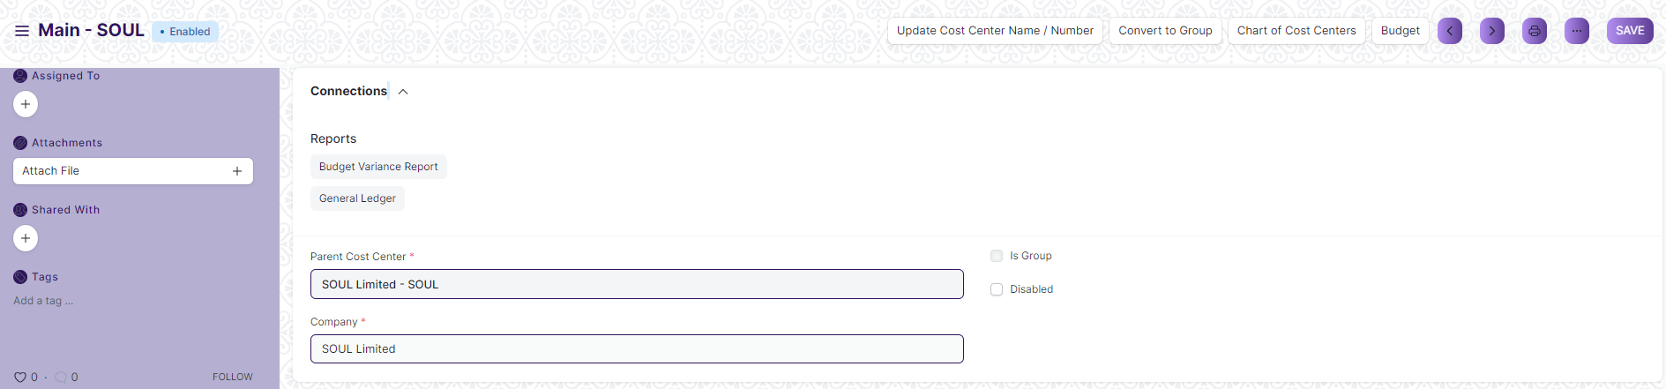

Figure: Cost Center Screen

**Field List**

The following table describes the UI fields present in this screen :

|  |  |  |  |  |  |  |
| --- | --- | --- | --- | --- | --- | --- |
| **ID** | **Field Name** | **Field Type** | **Mandatory** | **Validation/ Action** | **Remarks** | **R/N/D** |
| 1 | Cost Center Name | Data | Yes |  |  |  |
| 2 | Cost Center Number | Data |  |  |  |  |
| 3 | Parent Cost Center | Link | Yes |  |  |  |
| 4 | Company | Link | Yes | Link Fields to Master Screen Company | Default company name will be fetched |  |
| 5 | Is Group | Checkbox |  | If checked will create a group which can is visible under tree view |  |  |
| 6 | Disabled | Checkbox |  | If checked the cost center will be disabled |  |  |
| 7 | Update Cost Center Name / Number Button | | | On click you can update two fields i.e. Cost Center Name and Cost Center Number | Click this button to update cost center name or number |  |
| 8 | Convert to Group Button | | | Cost Center with existing transactions cannot be converted to group | Click this button to activate is group checkbox and make it a group which will be reflected under Chart of Cost Centers(tree view) |  |
| 9 | Chart of Cost Centers Button | | |  | This will open the tree view of cost centers |  |
| 10 | Budget Button | | |  | This will open the Budget screen of the application |  |

**User: Roles & Permission**

The following table describes the users and their roles and permissions for the screens :

|  |  |  |  |  |  |  |  |  |
| --- | --- | --- | --- | --- | --- | --- | --- | --- |
| **ID** | **Role** | **Read** | **Write** | **Create** | **Delete** | **Submit** | **Cancel** | **Amend** |
| 1 | Account User | No | No | No | No | NA | NA | NA |
| 2 | Account Manager | Yes | Yes | Yes | No | NA | NA | NA |
| 3 | Accountant Admin | Yes | Yes | Yes | No | NA | NA | NA |

### Accounting Dimension

**General Description**

The following table describes overall information about this screen:

|  |  |  |
| --- | --- | --- |
| **Description** | | 1. Dimensional accounting means tagging each transaction with appropriate dimensions like Branch, Business Unit, etc. This allows you to maintain each segment separately, thereby limiting the overall maintenance on GL accounts and your Chart of Accounts remains pure. 2. Cost Center is treated as dimensions by default in the application. On setting a field in Accounting Dimension, that field will be added in transactions reports where applicable. 3. In the application you can create configurable accounting dimensions and use them in transactions and reports. |
| **Navigation** | Home > Accounts > Cost Center > Accounting Dimension | |
| **Pre-requisites** | The system should have records in the following screen   1. Reference Document Type | |
| **Existing Screen Name** | Accounting Dimension | |
| **New Screen Name** | No change | |

**Screenshot**

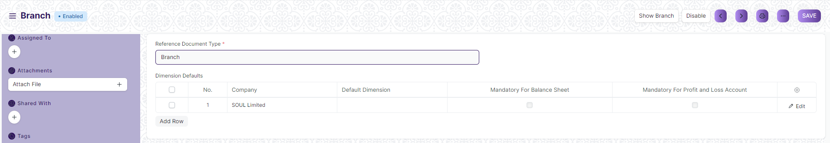

Figure: Accounting Dimension Screen

**Field List**

The following table describes the UI fields present in this screen :

|  |  |  |  |  |  |  |
| --- | --- | --- | --- | --- | --- | --- |
| **ID** | **Field Name** | **Field Type** | **Mandatory** | **Validation/ Action** | **Remarks** | **R/N/D** |
| 1 | Reference Document Type | Link | Yes |  | The Doc-type whose values are required as accounting dimension |  |
| 2 | Dimension Name | Data |  | Same as Reference Document Type |  |  |
| 3 | Fieldname | Data |  |  |  |  |
| 4 | Dimension Defaults | Table |  |  | Description of the table is given below |  |
| 5 | Disable | Checkbox |  | Disables the accounting dimension if checked |  |  |
|  | Show ““Reference Document Type”” button | | |  | This will redirect to the “Reference Document Type” |  |
|  | Enable/Disable button | | |  | This will enable/disable the accounting dimension |  |

|  |  |  |  |  |  |  |  |
| --- | --- | --- | --- | --- | --- | --- | --- |
| **Dimension Default (Accounting Dimension Detail)** | | | | | | | |
| **ID** | **Field Name** | **Field Type** | **Mandatory** | **Validation / Action** | | **Remarks** | **R/N/D** |
| 1 | Company | Link Field |  | This will fetch the default company of the application |  | |  |
| 2 | Reference Document | Link Field |  | This field is hidden |  | |  |
| 3 | Default Dimension | Dynamic Link Field |  |  | This is where you can mention company specific default dimensions.This dimension will be automatically fetched in the transaction against that specific company. | |  |
| 4 | Mandatory For Balance Sheet | Checkbox |  |  | Check "Mandatory" checkbox if you want the dimension to be mandatory in the transactions | |  |
| 5 | Mandatory For Profit and Loss Account | Checkbox |  |  | Check "Mandatory" checkbox if you want the dimension to be mandatory in the transactions | |  |

**User: Roles & Permission**

The following table describes the users and their roles and permissions for the screens :

|  |  |  |  |  |  |  |  |  |
| --- | --- | --- | --- | --- | --- | --- | --- | --- |
| **ID** | **Role** | **Read** | **Write** | **Create** | **Delete** | **Submit** | **Cancel** | **Amend** |
| 1 | Account User | No | No | No | No | NA | NA | NA |
| 2 | Account Manager | Yes | Yes | Yes | No | NA | NA | NA |
| 3 | Accountant Admin | Yes | Yes | Yes | No | NA | NA | NA |

## General Ledger and Accounting Entries

### Journal Entry

**General Description**

The following table describes overall information about this screen:

|  |  |
| --- | --- |
| **Description** | A Journal Entry is an entry made in the general ledger and it indicates the affected accounts. |
| **Navigation** | Home > Accounts > General Ledger > Journal Entry |
| **Pre-requisites** | The system should have records in the following screen   1. Company 2. Finance Book 3. Journal Entry Template 4. Account 5. Party Type 6. Party 7. Letter Head 8. Print Heading 9. Mode of Payment |
| **Existing Screen Name** | Journal Entry |
| **New Screen Name** | No change |

**Screenshot**

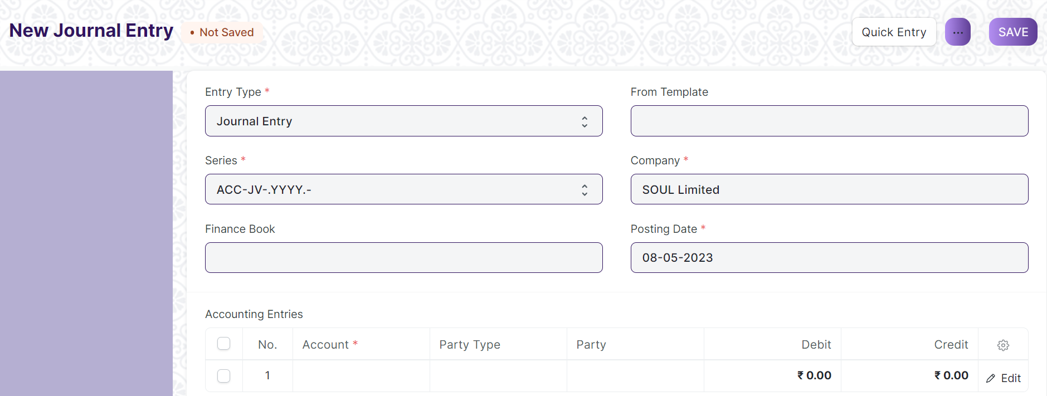Figure: Journal Entry

**Field List**

The following table describes the UI fields present in this screen :

|  |  |  |  |  |  |  |
| --- | --- | --- | --- | --- | --- | --- |
| **ID** | **Field Name** | **Field Type** | **Mandatory** | **Validation/ Action** | **Remarks** | **R/N/D** |
|  | Title | Text |  |  |  |  |
|  | Entry Type | Dropdown | Yes | Options:  Journal Entry  Inter Company Journal Entry  Bank Entry  Cash Entry  Credit Card Entry  Debit Note  Credit Note  Contra Entry  Excise Entry  Write Off Entry  Opening Entry  Depreciation Entry  Exchange Rate Revaluation  Deferred Revenue  Deferred Expense |  |  |
|  | Finance Book | Link Field |  | Link Fields to Finance Book Screen |  |  |
|  | Process Deferred Accounting | Link Field |  | Link Fields to Process Deferred Accounting Screen |  |  |
|  | Reversal Of | Link Field |  | Link Fields to Journal Entry Screen |  |  |
|  | Tax Withholding Category | Link Field |  | Link Fields to Tax Withholding Category Screen |  |  |
|  | From Template | Link Field |  | Link Fields to Journal Entry Template Screen |  |  |
|  | Company | Link Field | Yes | Link Fields to Company Screen |  |  |
|  | Posting Date | Date | Yes |  |  |  |
|  | Apply Tax Withholding Amount | Checkbox |  |  |  |  |
|  | Accounting Entries | Table | Yes | Journal Entry Account |  |  |
|  | Reference Number | Text |  |  |  |  |
|  | Reference Date | Date |  |  |  |  |
|  | User Remark | Small Text |  |  |  |  |
|  | Total Debit | Currency |  |  |  |  |
|  | Total Credit | Currency |  |  |  |  |
|  | Difference (Dr - Cr) | Currency |  |  |  |  |
|  | Make Difference Entry | Button |  |  |  |  |
|  | Multi Currency | Check box |  |  |  |  |
|  | Total Amount Currency | Link Field |  | Link Fields to Currency Screen |  |  |
|  | Total Amount | Currency |  |  |  |  |
|  | Total Amount in Words | Text |  |  |  |  |
|  | Clearance Date | Date |  |  |  |  |
|  | Remark | Small Text |  |  |  |  |
|  | Paid Loan | Text |  |  |  |  |
|  | Bill No | Text |  |  |  |  |
|  | Bill Date | Date |  |  |  |  |
|  | Due Date | Date |  |  |  |  |
|  | Get Outstanding Invoices | Button |  |  |  |  |
|  | Pay To / Recd From | Text |  |  |  |  |
|  | Letter Head | Link Field |  | Link Fields to Letter Head Screen |  |  |
|  | Print Heading | Link Field |  | Link Fields to Print Heading Screen |  |  |
|  | Mode of Payment | Link Field |  | Link Fields to Mode of Payment Screen |  |  |
|  | Payment Order | Link Field |  | Link Fields to Payment Order Screen |  |  |
|  | Is Opening | Dropdown |  | Options  No  Yes |  |  |
|  | Stock Entry | Link Fields |  | Link Fields to Stock Entry Screen |  |  |
|  | Auto Repeat | Link Fields |  | Link Fields to Auto Repeat Screen |  |  |
|  | Quick Entry | | | Action Button | On Click a Popup will open and the user need to enter the Credit account, Debit account, date, etc. |  |
|  | Amount | Text | Yes |  | On Click the Quick Entry Button, this field will visible inside a popup. |  |
|  | Debit Account | Link Field | Yes | Link Field to Account Screen | On Click the Quick Entry Button, this field will visible inside a popup. |  |
|  | Credit Account | Link Field | Yes |  | On Click the Quick Entry Button, this field will visible inside a popup. |  |
|  | Date | Date | Yes |  | On Click the Quick Entry Button, this field will visible inside a popup. |  |
|  | User Remark | Long Text |  |  | On Click the Quick Entry Button, this field will visible inside a popup. |  |
|  | Series | Naming Series | Yes | Create the unique naming series for the records. | On Click the Quick Entry Button, this field will visible inside a popup. |  |
|  | View --> Ledger (Custom Button) | | |  | On click the General Ledger Screen will open in report view. |  |
|  | Action --> Reverse Journal Entry (Custom Button) | | |  | It Creates another new record when user can do reverse journal entry. |  |

**User: Roles & Permission**

The following table describes the users and their roles and permissions for the screens :

|  |  |  |  |  |  |  |  |  |
| --- | --- | --- | --- | --- | --- | --- | --- | --- |
| **ID** | **Role** | **Read** | **Write** | **Create** | **Delete** | **Submit** | **Cancel** | **Amend** |
| 1 | Accountant Admin | Yes | Yes | Yes | No | Yes | Yes | Yes |
| 2 | Account Manager | Yes | Yes | Yes | No | Yes | Yes | Yes |
| 3 | Account User | Yes | Yes | Yes | No | Yes | Yes | Yes |

### GL Entry

**General Description:**

The following table describes overall information about this screen

|  |  |
| --- | --- |
| **Description :** | A general ledger (GL) is a set of numbered accounts a business uses to keep track of its financial transactions and to prepare financial reports. |
| **Navigation :** | Home > Accounts |
| **Pre-requisites** : | None |
| **Existing Screen Name** | GL Entry |
| **New Screen Name** | No Change |

**Screenshots:**

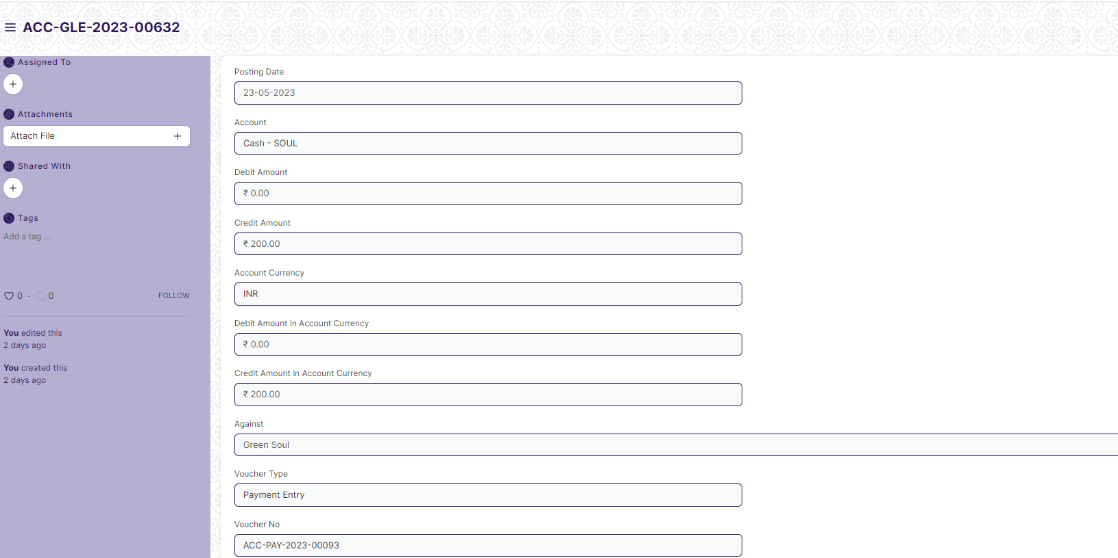

Figure: GL Entry

**Field List:**

The following table describes the UI fields present in this screen:

|  |  |  |  |  |  |  |
| --- | --- | --- | --- | --- | --- | --- |
| **ID** | **Field Name** | **Field Type** | **Mandatory** | **Validation/Action** | **Remarks** | **R/N/D** |
| 1 | Posting Date | Date |  |  |  |  |
| 2 | Transaction Date | Date |  |  |  |  |
| 3 | Account | Link Field |  | Link Field to Account Screen |  |  |
| 4 | Party Type | Link Field |  | Link Field to Party Type Screen |  |  |
| 5 | Party | Dynamic Link |  |  |  |  |
| 6 | Cost Center | Link Field |  | Link Field to Party Type Screen |  |  |
| 7 | Debit Amount | Currency |  |  |  |  |
| 8 | Credit Amount | Currency |  |  |  |  |
| 9 | Account Currency | Link Field |  | Link Field to Currency Screen |  |  |

**User: Roles & Permission**

The following table describes the users and their roles and permissions for the screens :

|  |  |  |  |  |  |  |  |  |
| --- | --- | --- | --- | --- | --- | --- | --- | --- |
| **ID** | **Role** | **Read** | **Write** | **Create** | **Delete** | **Submit** | **Cancel** | **Amend** |
| 1 | Account User | No | No | No | No | NA | NA | NA |
| 2 | Account Manager | No | No | No | No | NA | NA | NA |
| 3 | Accountant Admin | No | No | No | No | NA | NA | NA |

### General Ledger

**General Description**

The following table describes overall information about this screen:

|  |  |
| --- | --- |
| Description | * The General Ledger is a detailed report for all transactions posted to each account and for every transaction there is a Credit and Debit account so it lists them all up. * The report is based on the table GL Entry and can be filtered by many predefined filters like Account, Cost Centers, Party, Project and Period etc. This helps you to get a full update for all entries posted in a period against any account. * The result can be grouped by Account, Voucher/Transaction and Party with opening and closing balances for each group. * In case of multi-currency accounting, there is also an option to check the amounts in any other currency than the company's base currency. |
| Navigation | Home > Accounts > General Ledger > General Ledger |
| Pre-requisites | The system should have records in the following screen   1. Company 2. Finance Book 3. Account |
| Existing Screen Name | General Ledger |
| New Screen Name | No change |

**Screenshot**

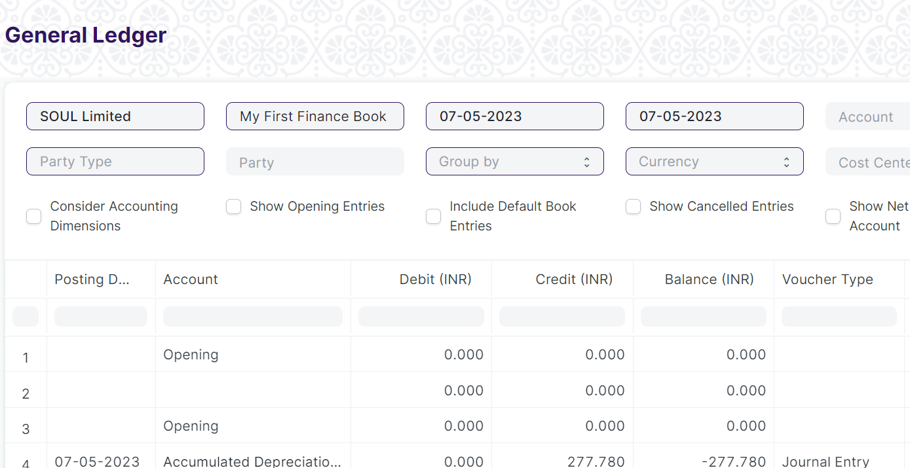

Figure: General Ledger

**Input Filters:**

|  |  |  |  |  |  |  |
| --- | --- | --- | --- | --- | --- | --- |
| **ID** | **Input Fields** | **Field Type** | **Mandatory** | **Validation/ Action** | **Remarks** | **R/N/D** |
|  | Company | Link Field |  | Link Fields to Company Screen |  |  |
|  | Finance Book | Link Field |  | Link Fields to Finance Book Screen |  |  |
|  | From Date | Date |  | From date should be before the To date |  |  |
|  | To Date | Date |  | To date should be after from date |  |  |
|  | Account | Link Field |  | Link Fields to Account Screen |  |  |
|  | Voucher No | Text |  |  |  |  |
|  | Party Type | Link Field |  | Link Fields to Customer, Supplier, Student, Employee Screen |  |  |
|  | Party | Link Field |  | Link fields depends upon the party type |  |  |
|  | Group Name | Dropdown |  | Options:   1. Group by Voucher 2. Group by Voucher (Consolidated) 3. Group by Account 4. Group by Party |  |  |
|  | Currency | Dropdown |  | Options:   1. AED 2. AUD 3. CHF 4. CNY 5. EUR 6. GBP 7. INR 8. JPY 9. USD |  |  |
|  | Cost Center | Link Field |  | Link Fields to Cost Center Master Screen |  |  |
|  | Project | Link Field |  | Link Fields to Project Screen |  |  |
|  | Consider Accounting Dimensions | Check box |  | On Check Accounting Dimensions will be considered. |  |  |
|  | Show Opening Entries | Check box |  | On Check It will show the Opening Entries only. |  |  |
|  | Include Default Book Entries | Check box |  | On Check It includes default book entries |  |  |
|  | Show Cancelled Entries | Check box |  | On Check It will show only Cancelled entries. |  |  |
|  | Show Net Values in Party Account | Check box |  | On Check It shows the net values in Party Account |  |  |

**Actions**

* User will enter the search fields such as: Account, Voucher No, etc. Based on that input, the report will be shown.
* User can add or remove the headers with the help of Add Column or Remove Column button.

**Report Fields**

|  |  |  |
| --- | --- | --- |
| **ID** | **Column Name** | **Description** |
|  | Posting Date | It is the document posting date |
|  | Account | Name of the Account Type |
|  | Debit | Debited Amount |
|  | Credit | Credited Amount |
|  | Balance | Debit - Credit = Balance |
|  | Voucher Type | Different Types of Vouchers like Purchase Receipt, Stock Entry, etc. |
|  | Voucher No | Voucher no. is based on the voucher type. |
|  | Against Account | Different Types of Vouchers like Purchase Receipt, Stock Entry, etc. |
|  | Party Type | Voucher no. is based on the voucher type. |
|  | Party | A specific Supplier, Customer or Student depending on the option you choose for the Party Type. |
|  | Cost Center | It is a part of an organization where costs or income can be charged. |
|  | Project | Name of the Project |
|  | Against Voucher Type | Payment made against a particular voucher type. |
|  | Against Voucher | Payment made against a particular voucher number. |
|  | Supplier Invoice No | Shows the Supplier Invoice Number. |
|  | Remarks | Remarks given w.r.t. the Party Name |

**User: Roles & Permission**

The following table describes the users and their roles and permissions for the screens :

|  |  |  |  |  |  |  |  |  |
| --- | --- | --- | --- | --- | --- | --- | --- | --- |
| **ID** | **Role** | **Read** | **Write** | **Create** | **Delete** | **Submit** | **Cancel** | **Amend** |
| 1 | Accountant Admin | Yes | Yes | NA | NA | NA | NA | NA |
| 2 | Account Manager | Yes | Yes | NA | NA | NA | NA | NA |
| 3 | Account User | Yes | Yes | NA | NA | NA | NA | NA |

### Payment Entry

**General Description**

The following table describes overall information about this screen:

|  |  |
| --- | --- |
| **Description** | Payment Entry is a record indicating that payment has been made for an invoice.  Payment Entry can be made against the following transactions.   1. Purchase Invoice 2. Purchase Order (Advance Payment) 3. Expense Claim |
| **Navigation** | Home > Accounts > Account Receivable > Payment Entry |
| **Pre-requisites** | The system should have records in the following screen   1. Mode of Payment 2. Account 3. Party Type 4. Party 5. Company 6. Currency 7. Tax Withholding Category 8. Cost Center |
| **Existing Screen Name** | Payment Entry |
| **New Screen Name** | No change |

**Screenshot**

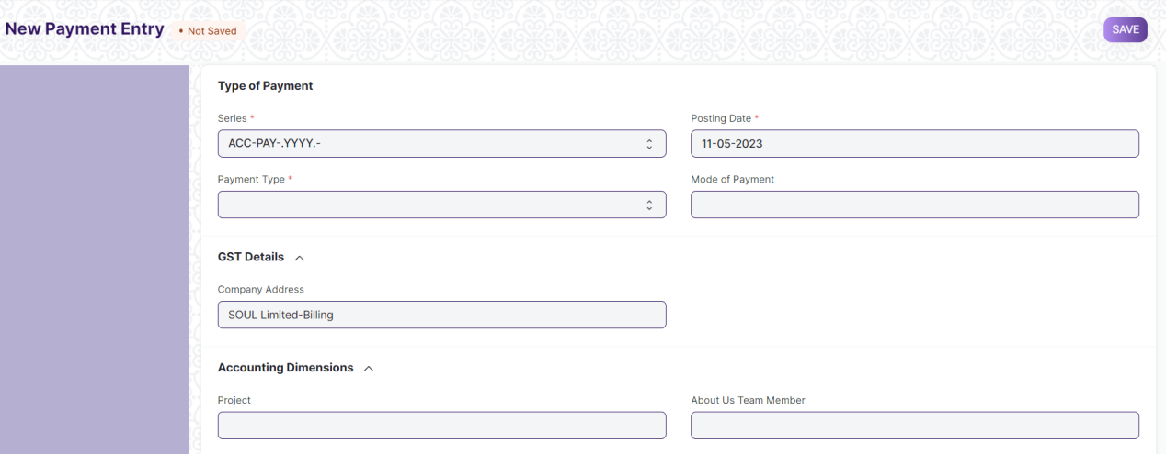

Figure: Payment Entry

**Field List**

The following table describes the UI fields present in this screen :

|  |  |  |  |  |  |  |
| --- | --- | --- | --- | --- | --- | --- |
| **ID** | **Field Name** | **Field Type** | **Mandatory** | **Validation/ Action** | **Remarks** | **R/N/D** |
|  | Payment Type | Dropdown | Yes | Options:  Receive Pay Internal Transfer |  |  |
|  | Payment Order Status | Dropdown |  | Options:  Initiated  Payment Ordered |  |  |
|  | Posting Date | Date | Yes |  |  |  |
|  | Company | Link Field | Yes | Link Field to Company Screen |  |  |
|  | Mode of Payment | Link Field |  | Link Field to Mode of Payment Screen |  |  |
|  | Party Type | Link Field |  | Link Field to Employee, Customer, Student, Share holder, Supplier Screen |  |  |
|  | Party | Dynamic Link |  | On the basis of Party Type selected by the user, Dynamic Link Field will be visible accordingly. |  |  |
|  | Party Name | Text |  | Auto fetched when Party entered |  |  |
|  | Company Bank Account | Link Field |  | Link Field to Account Screen |  |  |
|  | Party Bank Account | Link Field |  | Link Field to Account Screen |  |  |
|  | Contact | Link Field |  | Link Field to Contact Screen |  |  |
|  | Email | Text |  |  |  |  |
|  | Party Balance | Currency |  |  |  |  |
|  | Account Paid From | Link Field | Yes | Link Field to Account Screen | When user entered payment type equal to Internal transfer then only this field will be visible. |  |
|  | Paid From Account Type | Text |  |  |  |  |
|  | Account Currency (From) | Link Field | Yes | Link Field to Currency Screen | It will be visible When Account Paid From data is entered |  |
|  | Account Balance (From) | Currency |  |  |  |  |
|  | Account Paid To | Link Field | Yes | Link Field to Currency Screen | When user entered payment type equal to Internal transfer then only this field will be visible. |  |
|  | Paid To Account Type | Text |  |  |  |  |
|  | Account Currency (To) | Link Field | Yes | Link Field to Currency Screen | It will be visible When Account Paid To data is entered |  |
|  | Account Balance (To) | Currency |  |  | It will be visible When Account Paid To data is entered |  |
|  | Paid Amount | Currency | Yes |  | It will be visible When Account Paid To data is entered |  |
|  | Paid Amount After Tax | Currency |  |  |  |  |
|  | Source Exchange Rate | Float | Yes |  |  |  |
|  | Paid Amount (Company Currency) | Currency | Yes |  |  |  |
|  | Paid Amount After Tax (Company Currency) | Currency |  |  |  |  |
|  | Received Amount | Currency | Yes |  | It will be visible When Account Paid To data is entered |  |
|  | Received Amount After Tax | Currency |  |  |  |  |
|  | Target Exchange Rate | Float | Yes |  |  |  |
|  | Received Amount (Company Currency) | Currency | Yes |  |  |  |
|  | Received Amount After Tax (Company Currency) | Currency |  |  |  |  |
|  | Get Outstanding Invoice | Button |  |  |  |  |
|  | **Payment References** | Table |  |  |  |  |
|  | Total Allocated Amount | Currency |  |  |  |  |
|  | Total Allocated Amount (Company Currency) | Currency |  |  |  |  |
|  | Set Exchange Gain / Loss | Button |  |  |  |  |
|  | Unallocated Amount | Currency |  |  |  |  |
|  | Difference Amount (Company Currency) | Currency |  |  |  |  |
|  | Write Off Difference Amount | Button |  |  |  |  |
|  | Purchase Taxes and Charges Template | Link Field |  | Link Field to Purchase Taxes and Charges Template Screen |  |  |
|  | Apply Tax Withholding Amount | Checkbox |  |  |  |  |
|  | Tax Withholding Category | Link Field |  | Link Field to Tax Withholding Category Screen |  |  |
|  | **Advance Taxes and Charges** | Table |  |  |  |  |
|  | Total Taxes and Charges (Company Currency) | Currency |  |  |  |  |
|  | Total Taxes and Charges | Currency |  |  |  |  |
|  | **Payment Deductions or Loss** | Table |  |  |  |  |
|  | Cheque/Reference No | Text |  |  | It will visible When Mode of Payment equals to Cheque |  |
|  | Cheque/Reference Date | Date |  |  | It will visible When Mode of Payment equals to Cheque |  |
|  | Clearance Date | Date |  |  |  |  |
|  | Project | Link Field |  | Link Field to Project Screen |  |  |
|  | Cost Center | Link Field |  | Link Field to Cost Center Screen |  |  |
|  | Status | Dropdown |  | Options:  Draft  Submitted  Cancelled |  |  |
|  | Remarks | Small Text |  |  |  |  |
|  | Letter Head | Link Field |  | Link Field to Company Screen |  |  |
|  | Print Heading | Link Field |  | Link Field to Company Screen |  |  |
|  | Bank | Read Only |  |  |  |  |
|  | Bank Account No | Read Only |  |  |  |  |
|  | Payment Order | Link Field |  | Link Field to Payment Order Screen |  |  |
|  | Auto Repeat | Link Field |  | Link Field to Auto Repeat Screen |  |  |
|  | Title | Text |  |  |  |  |

|  |  |  |  |  |  |  |
| --- | --- | --- | --- | --- | --- | --- |
| **Payment References** | | | | | | |
| **ID** | **Field Name** | **Field Type** | **Mandatory** | **Validation/ Action** | **Remarks** | **R/N/D** |
|  | Type | Link Field | Yes | Link Field to Supplier, Customer, Student, Employee Screen |  |  |
|  | Name | Dynamic Link Field | Yes | Dropdown data will come w.r.t. the Type |  |  |
|  | Due Date | Date |  |  |  |  |
|  | Supplier Invoice No | Text |  |  |  |  |
|  | Payment Term | Link Field |  | Link Field to Payment Term Screen |  |  |
|  | Grand Total | Float |  |  |  |  |
|  | Outstanding | Float |  |  |  |  |
|  | Allocated | Float |  |  |  |  |
|  | Exchange Rate | Float |  |  |  |  |
|  | Exchange Gain/Loss | Currency |  |  |  |  |
| **Advance Taxes and Charges** | | | | | | |
| **ID** | **Field Name** | **Field Type** | **Mandatory** | **Validation/ Action** | **Remarks** | **R/N/D** |
|  | Add Or Deduct | Dropdown | Yes | Option:  Add  Deduct |  |  |
|  | Type | Dropdown | Yes | Option:   1. Actual 2. On Paid Amount 3. On Previous Row Amount 4. On Previous Row Total |  |  |
|  | Account Head | Link Field | Yes | Link Filed to Account Screen |  |  |
|  | Description | Long Text | Yes |  |  |  |
|  | Considered In Paid Amount | Check Box |  | Link Field to Payment Term Screen |  |  |
|  | Cost Center | Link Field |  | Link field to Cost Center Screen |  |  |
|  | Rate | Float |  |  |  |  |
|  | Account Currency | Link Field |  | Link field to Currency Screen |  |  |
|  | Amount | Currency |  |  |  |  |
|  | Total | Currency |  |  |  |  |
|  | Allocated Amount | Currency |  |  |  |  |
| **Payment Deductions or Loss** | | | | | | |
| **ID** | **Field Name** | **Field Type** | **Mandatory** | **Validation/ Action** | **Remarks** | **R/N/D** |
|  | Account | Link Field | Yes | Link Field to Account Screen |  |  |
|  | Cost Center | Link Field | Yes | Link Field to Cost Center Screen |  |  |
|  | Amount | Currency | Yes |  |  |  |
|  | Description | Long Text |  |  |  |  |

**User: Roles & Permission**

The following table describes the users and their roles and permissions for the screens :

|  |  |  |  |  |  |  |  |  |
| --- | --- | --- | --- | --- | --- | --- | --- | --- |
| **ID** | **Role** | **Read** | **Write** | **Create** | **Delete** | **Submit** | **Cancel** | **Amend** |
| 1 | Accountant Admin | Yes | Yes | Yes | No | Yes | Yes | Yes |
| 2 | Account Manager | Yes | Yes | Yes | No | Yes | No | Yes |
| 3 | Account User | Yes | Yes | Yes | No | Yes | No | Yes |

## Bank Statement

### Bank Reconciliation Tool

**General Description**

The following table describes overall information about this screen:

|  |  |  |
| --- | --- | --- |
| **Description** | | 1. Once all your bank transactions are imported into the application, you can reconcile them with your existing vouchers. 2. The final goal of Bank Reconciliation is to make the difference amount zero (green) by either matching to an existing voucher or creating a new voucher. |
| **Navigation** | Home > Accounts > Bank Statement > Bank Reconciliation Tool | |
| **Pre-requisites** | The system should have records in the following screen   1. Payment Entries 2. Bank Statement | |
| **Existing Screen Name** | Bank Reconciliation Tool | |
| **New Screen Name** | No change | |

**Screenshot**

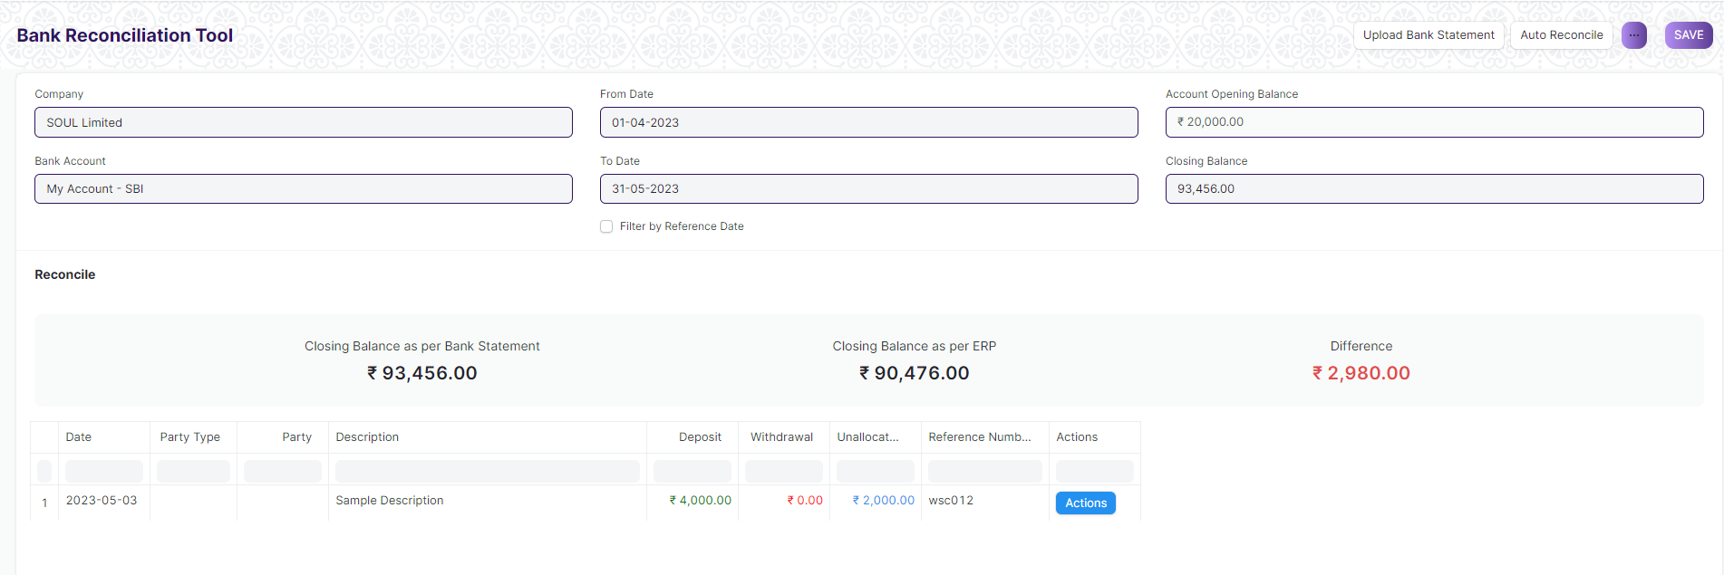

Figure: Bank Reconciliation Tool Screen

**Field List**

The following table describes the UI fields present in this screen :

|  |  |  |  |  |  |  |
| --- | --- | --- | --- | --- | --- | --- |
| **ID** | **Field Name** | **Field Type** | **Mandatory** | **Validation/ Action** | **Remarks** | **R/N/D** |
| 1 | Company | Link Field |  | Link Fields to Master Screen Company | Default company name will be fetched |  |
| 2 | Bank Account | Link Field |  | Link Fields to Master Screen Bank Account | Default bank account name will be fetched |  |
| 3 | From Date | Date |  |  |  |  |
| 4 | To Date | Date |  | To Date shall be greater than From date |  |  |
| 5 | From Reference Date | Date |  |  |  |  |
| 6 | To Reference Date | Date |  | To Reference Date shall be greater than From Reference Date |  |  |
| 7 | Filter by Reference Date | Checkbox |  | If checked fields ‘From Reference Date’ and ‘ To Reference Date’ will be displayed instead of ‘From Date’ and ‘To Date’ and vice versa |  |  |
| 8 | Account Opening Balance | Currency |  |  |  |  |
| 10 | Closing Balance | Currency |  |  | Enter the closing balance as per bank statement |  |
| 11 | Reconciliation Tool Cards | HTML |  |  | Displays the ‘Closing Balance as per Bank Statement’ , ‘Closing Balance as per ERP’ and the difference |  |
| 12 | Bank Transactions | HTML |  | For all the bank transactions which are present in the Bank Statement but do not have a clearance date, click on the Actions Button to Match/ Create Vouchers |  |  |
| 13 | Upload Bank Statement Button | | | Make sure you have at least the date, the debit/credit and the currency on every row of your bank statement | Download a bank statement from your bank's website |  |
| 14 | Auto Reconcile Button | | |  | Click on ‘Auto Reconcile’ button to reconcile against matching references |  |

**User: Roles & Permission**

The following table describes the users and their roles and permissions for the screens :

|  |  |  |  |  |  |  |  |  |
| --- | --- | --- | --- | --- | --- | --- | --- | --- |
| **ID** | **Role** | **Read** | **Write** | **Create** | **Delete** | **Submit** | **Cancel** | **Amend** |
| 1 | Account User | No | No | No | No | NA | NA | NA |
| 2 | Account Manager | Yes | Yes | Yes | No | NA | NA | NA |
| 3 | Accountant Admin | Yes | Yes | Yes | No | NA | NA | NA |

### Bank Clearance

**General Description**

The following table describes overall information about this screen:

|  |  |  |
| --- | --- | --- |
| **Description** | | 1. This feature is used to manually update clearance date with respect to payment entries which are not reconciled 2. You can also use this feature to update or rectify clearance date of reconciled transactions |
| **Navigation** | Home > Accounts > Bank Statement > Bank Clearance | |
| **Pre-requisites** | The system should have records in the following screen   1. Account 2. Account Currency | |
| **Existing Screen Name** | Bank Clearance | |
| **New Screen Name** | No change | |

**Screenshot**

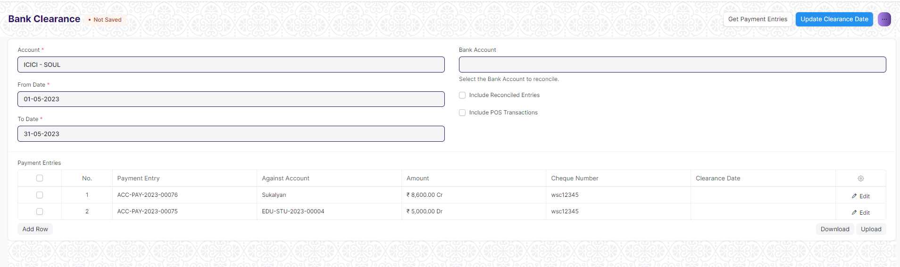

Figure: Bank Clearance Screen

**Field List**

The following table describes the UI fields present in this screen :

|  |  |  |  |  |  |  |
| --- | --- | --- | --- | --- | --- | --- |
| **ID** | **Field Name** | **Field Type** | **Mandatory** | **Validation/ Action** | **Remarks** | **R/N/D** |
| 1 | Account | Link Field | Yes | Link Fields to Master Screen Account | Default account name will be fetched |  |
| 2 | Account Currency | Link Field |  | Link Fields to Master Screen Currency | This field is hidden |  |
| 3 | From Date | Date | Yes |  |  |  |
| 4 | To Date | Date | Yes | To Date shall be greater than From date |  |  |
| 5 | Bank Account | Link Field |  | Link Fields to Master Screen Bank Account |  |  |
| 6 | Include Reconciled Entries | Checkbox |  | If checked reconciled entries will be fetched |  |  |
| 7 | Include POS Transactions | Checkbox |  | If checked POS Transactions will fetch |  |  |
| 8 | Payment Entries | Table |  | Description of the Table is given below | Once clearance date is updated the entries disappear from the table |  |
| 9 | Get Payment Entries Button | | | Payment Entries table is filled with relevant data once clicked |  |  |
| 10 | Update Clearance Date Button | | | Set the clearance date for the relevant payment entries and then click on this button to update clearance date |  |  |

|  |  |  |  |  |  |  |  |
| --- | --- | --- | --- | --- | --- | --- | --- |
| **Payment Entries(Bank Clearance Detail)** | | | | | | | |
| **ID** | **Field Name** | **Field Type** | **Mandatory** | **Validation / Action** | | **Remarks** | **R/N/D** |
| 1 | Payment Document | Link Field |  | Links to Doctype List | Data fetches on click “Get Payment Entries” button | |  |
| 2 | Payment Entry | Dynamic Link Field |  | Links to Doctype selected in Payment Document | Data fetches on click “Get Payment Entries” button | |  |
| 3 | Against Account | Data |  |  | Data fetches on click “Get Payment Entries” button | |  |
| 4 | Amount | Data |  |  | Data fetches on click “Get Payment Entries” button | |  |
| 5 | Posting Date | Date |  |  | Data fetches on click “Get Payment Entries” button | |  |
| 6 | Cheque Number | Data |  |  | Data fetches on click “Get Payment Entries” button | |  |
| 7 | Cheque Date | Date |  |  | Data fetches on click “Get Payment Entries” button | |  |
| 8 | Clearance Date | Date |  |  | Enter clearance date and click on “update clearance date” button | |  |

**User: Roles & Permission**

The following table describes the users and their roles and permissions for the screens :

|  |  |  |  |  |  |  |  |  |
| --- | --- | --- | --- | --- | --- | --- | --- | --- |
| **ID** | **Role** | **Read** | **Write** | **Create** | **Delete** | **Submit** | **Cancel** | **Amend** |
| 1 | Account User | No | No | No | No | NA | NA | NA |
| 2 | Account Manager | Yes | Yes | Yes | No | NA | NA | NA |
| 3 | Accountant Admin | Yes | Yes | Yes | No | NA | NA | NA |

### Bank Reconciliation Statement

**General Description**

The following table describes overall information about this screen:

|  |  |
| --- | --- |
| Description | The Bank Reconciliation Report provides the difference between the bank balance shown in an organization's bank statement, as provided by the bank against the amount shown in the companies Chart of Accounts. |
| Navigation | Home > Accounts > Bank Statement > Bank Reconciliation Statement |
| Pre-requisites | The system should have records in the following screen   1. GL Entries 2. Payment Entries |
| Existing Screen Name | Bank Reconciliation Statement |
| New Screen Name | No change |

**Screenshot**

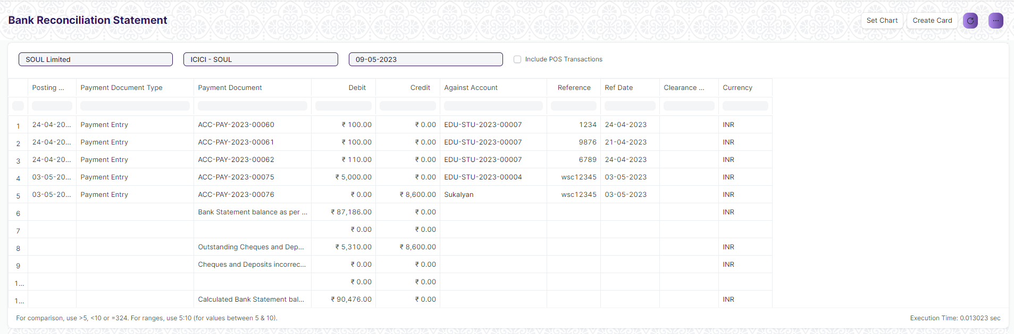

Figure: Bank Reconciliation Statement Screen

**Input Filters**

|  |  |  |  |  |  |  |
| --- | --- | --- | --- | --- | --- | --- |
| **ID** | **Input Fields** | **Field Type** | **Mandatory** | **Validation/ Action** | **Remarks** | **R/N/D** |
|  | Company | Link Field |  |  | Default Company will be fetched |  |
|  | Bank Account | Link Field |  |  | Default Bank Account will be fetched |  |
|  | Date | Date |  |  | Today’s date will be auto-fetched |  |

**Actions**

* User will enter the search fields such as Date and Bank Account as per requirement
* A user can add or remove the headers with the help of Add Column or Remove Column button.

**Report Fields**

|  |  |  |
| --- | --- | --- |
| **ID** | **Column Name** | **Description** |
|  | Posting Date | This displays the posting date of the transaction |
|  | Payment Document Type | This displays the type of voucher associated to the payment |
|  | Payment Document | This shows the primary key of the payment voucher |
|  | Debit | This shows the credit amount |
|  | Credit | This shows the debit amount |
|  | Against Account | This shows the party against which the amount was charged |
|  | Reference | This shows the reference number against transactions, if any |
|  | Ref Date | This shows the reference date against transactions, if any |
|  | Clearance Date | It shows the clearance date of the transactions, if any |
|  | Currency | It shows the currency such as INR, USD, etc. |

**User: Roles & Permission**

The following table describes the users and their roles and permissions for the screens :

|  |  |  |  |  |  |  |  |  |
| --- | --- | --- | --- | --- | --- | --- | --- | --- |
| **ID** | **Role** | **Read** | **Write** | **Create** | **Delete** | **Submit** | **Cancel** | **Amend** |
| 1 | Accountant Admin | Yes | Yes | NA | NA | NA | NA | NA |
| 2 | Account Manager | Yes | Yes | NA | NA | NA | NA | NA |
| 3 | Account User | Yes | Yes | NA | NA | NA | NA | NA |

## Reports

### Accounts Receivable

### 4.1.1 Accounts Receivable Report

**General Description**

The following table describes overall information about this screen:

|  |  |
| --- | --- |
| **Description** | This reports help you to track the outstanding amount of Students and other parties. It also provides ageing analysis i.e. a break-up of outstanding amount based on the period for which the amount is outstanding. |
| **Navigation** | Home > Accounts > Account Receivable > Account Receivable |
| **Pre-requisites** | The system should have records in the following screen   1. Company 2. Finance Book 3. Cost Center 4. Student |
| **Existing Screen Name** | Account Receivable |
| **New Screen Name** | No change |

**Screenshot**

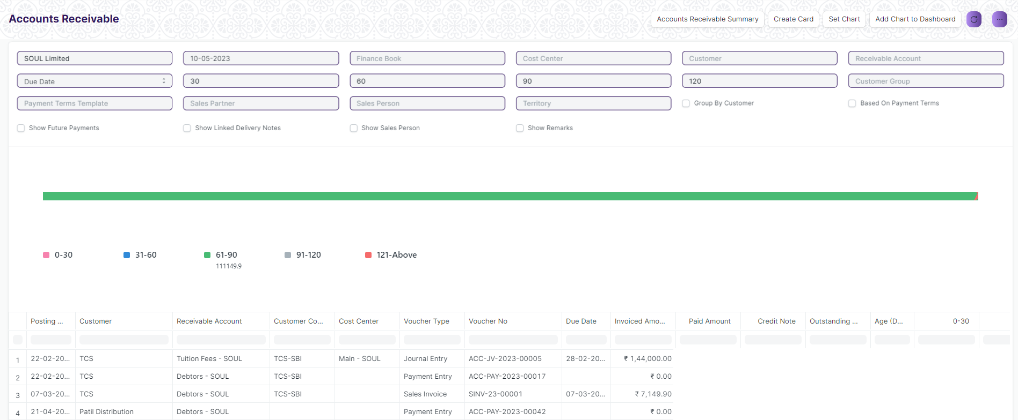

Figure: Account Receivable

**Input Filters**

|  |  |  |  |  |  |  |
| --- | --- | --- | --- | --- | --- | --- |
| **ID** | **Input Fields** | **Field Type** | **Mandatory** | **Validation/ Action** | **Remarks** | **R/N/D** |
|  | Company | Link Field |  |  |  |  |
|  | Posting Date | Date |  | From date should be before the To date |  |  |
|  | Finance Book | Link Field |  | Link Fields to Finance Book Screen |  |  |
|  | Cost Center | Link Field |  | Link Fields to Cost Center Screen |  |  |
|  | Customer | Link Field |  | Link Fields to Customer Screen |  |  |
|  | Receivable Account | Link Field |  | Link Fields to Receivable Account Screen |  |  |
|  | Due Date | Date |  |  |  |  |
|  | Ageing Range 1 | Text |  |  |  |  |
|  | Ageing Range 2 | Text |  |  |  |  |
|  | Ageing Range 3 | Text |  |  |  |  |
|  | Ageing Range 4 | Text |  |  |  |  |
|  | Customer Group | Link Field |  | Link Fields to Customer Group Screen |  |  |
|  | Payment Term Template | Link Field |  | Link Fields to Payment Term Template Screen |  |  |
|  | Sales Partner | Link Field |  | Link Fields to Sales Partner Screen |  |  |
|  | Sales Person | Link Field |  | Link Fields to Sales Person Screen |  |  |
|  | Territory | Link Field |  | Link Fields to Territory Screen |  |  |
|  | Group by Customer | Check box |  | Link Fields to Group by Customer Screen |  |  |
|  | Based on Payment Term | Check box |  |  | On check, data will be visible Based on Payment Term |  |
|  | Show Future Payments | Check box |  |  | On check, it will also show the future payments |  |
|  | Show Linked Delivery Notes | Check box |  |  | On check, It will show the linked delivery notes |  |
|  | Show Sales Person | Check box |  |  | On check, It will show the sales person details |  |
|  | Show Remarks | Check box |  |  | On check, It will show the remarks. |  |

**Actions**

* User will enter the search fields such as: Finance Book, Posting Date, etc. Based on that input, the report will be shown.
* A user can add or remove the headers with the help of Add Column or Remove Column button.

**Report Fields**

|  |  |  |
| --- | --- | --- |
| **ID** | **Column Name** | **Description** |
|  | Posting Date | It is the document posting date |
|  | Customer | It will show the customer names |
|  | Receivable Account | It shows the receivable account name |
|  | Customer Contact | It shows the customer contact details |
|  | Cost Center | It is a part of an organization where costs or income can be charged. |
|  | Voucher Type | Different Types of Vouchers like Purchase Receipt, Stock Entry, etc. |
|  | Voucher No | Voucher no. is based on the voucher type. |
|  | Due Date | It shows the due date for a particular transaction |
|  | Invoice Amount | It will shows the Invoice amount with respect to the individual customers |
|  | Paid Amount | It will shows the paid amount with respect to the individual customers |
|  | Credit Note | It is a document send by a buyer to the supplier notifying that a credit has been recorded. |
|  | Outstanding Amount | It will shows the outstanding amount with respect to the individual customers |

**User: Roles & Permission**

The following table describes the users and their roles and permissions for the screens :

|  |  |  |  |  |  |  |  |  |
| --- | --- | --- | --- | --- | --- | --- | --- | --- |
| **ID** | **Role** | **Read** | **Write** | **Create** | **Delete** | **Submit** | **Cancel** | **Amend** |
| 1 | Accountant Admin | Yes | Yes | NA | NA | NA | NA | NA |
| 2 | Account Manager | Yes | Yes | NA | NA | NA | NA | NA |
| 3 | Account User | Yes | Yes | NA | NA | NA | NA | NA |

### 4.1.2 Accounts Receivable Summary Report

**General Description**

The following table describes overall information about this screen:

|  |  |
| --- | --- |
| **Description** | * This reports help you to track the outstanding amount of Student and other parties. It also provides ageing analysis i.e. a break-up of outstanding amount based on the period for which the amount is outstanding. * It mainly shows the Receivable Account Details with respect to Individual Supplier Wise |
| **Navigation** | Home > Accounts > Account Receivable > Account Receivable Summary |
| **Pre-requisites** | The system should have records on the following screen   1. Company 2. Finance Book 3. Cost Center 4. Student |
| **Existing Screen Name** | Account Receivable Summary |
| **New Screen Name** | No change |

**Screenshot**

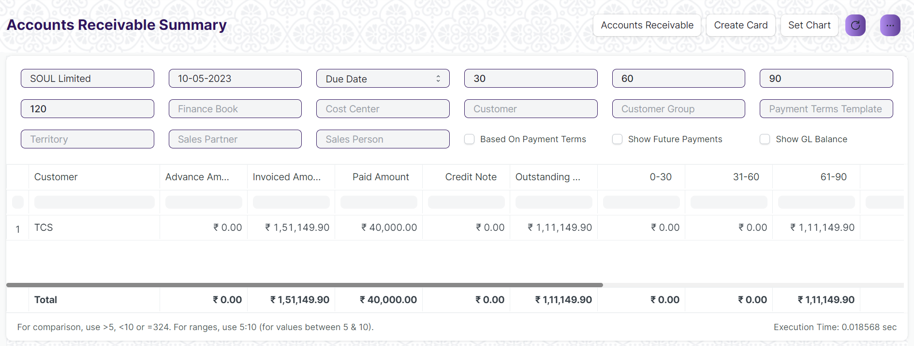Figure: Account Receivable Summary

**Input Filters**

|  |  |  |  |  |  |  |
| --- | --- | --- | --- | --- | --- | --- |
| **ID** | **Input Fields** | **Field Type** | **Mandatory** | **Validation/ Action** | **Remarks** | **R/N/D** |
|  | Company | Link Field |  |  |  |  |
|  | Posting Date | Date |  | From date should be before the To date |  |  |
|  | Ageing Based on | Dropdown |  | Options:  Due Date  Posting Date |  |  |
|  | Finance Book | Link Field |  | Link Fields to Finance Book Screen |  |  |
|  | Cost Center | Link Field |  | Link Fields to Cost Center Screen |  |  |
|  | Customer | Link Field |  | Link Fields to Customer Screen |  |  |
|  | Due Date | Date |  |  |  |  |
|  | Ageing Range 1 | Text |  |  |  |  |
|  | Ageing Range 2 | Text |  |  |  |  |
|  | Ageing Range 3 | Text |  |  |  |  |
|  | Ageing Range 4 | Text |  |  |  |  |
|  | Customer Group | Link Field |  | Link Fields to Customer Group Screen |  |  |
|  | Payment Term Template | Link Field |  | Link Fields to Payment Term Template Screen |  |  |
|  | Sales Partner | Link Field |  | Link Fields to Sales Partner Screen |  |  |
|  | Sales Person | Link Field |  | Link Fields to Sales Person Screen |  |  |
|  | Territory | Link Field |  | Link Fields to Territory Screen |  |  |
|  | Based on Payment Term | Check box |  |  | On check, data will be visible Based on Payment Term |  |
|  | Show Future Payments | Check box |  |  | On check, it will also show the future payments |  |
|  | Show GL Balance | Check box |  |  | On check, It will show the linked delivery notes |  |

**Actions**

* User will enter the search fields such as: Finance Book, Posting Date, etc. Based on that input, the report will be shown.
* A user can add or remove the headers with the help of Add Column or Remove Column button.

**Report Fields**

|  |  |  |
| --- | --- | --- |
| **ID** | **Column Name** | **Description** |
|  | Customer | It will show the customer names |
|  | Advance Amount | It shows the Advance amount with respect to the individual customers |
|  | Invoice Amount | It will shows the Invoice amount with respect to the individual customers |
|  | Paid Amount | It will shows the paid amount with respect to the individual customers |
|  | Credit Note | It is a document send by a buyer to the supplier notifying that a credit has been recorded. |
|  | Outstanding Amount | It will shows the outstanding amount with respect to the individual customers |
|  | Currency | It shows the currency such as INR, USD, etc. |

**User: Roles & Permission**

The following table describes the users and their roles and permissions for the screens :

|  |  |  |  |  |  |  |  |  |
| --- | --- | --- | --- | --- | --- | --- | --- | --- |
| **ID** | **Role** | **Read** | **Write** | **Create** | **Delete** | **Submit** | **Cancel** | **Amend** |
| 1 | Accountant Admin | Yes | Yes | NA | NA | NA | NA | NA |
| 2 | Account Manager | Yes | Yes | NA | NA | NA | NA | NA |
| 3 | Account User | Yes | Yes | NA | NA | NA | NA | NA |

### Accounts Payable

### 4.2.1 Accounts Payable Report

**General Description**

The following table describes overall information about this screen:

|  |  |
| --- | --- |
| Description | This report helps you to track the outstanding amount of Suppliers.  It also provides ageing analysis i.e. a break-up of outstanding amount based on the period for which the amount is outstanding. |
| Navigation | Home > Accounts > Accounts Payable > Accounts Payable |
| Pre-requisites | The system should have records in the following screen   1. Company 2. GL Entries 3. Payment Entries 4. Purchase Invoice |
| Existing Screen Name | Accounts Payable |
| New Screen Name | No change |

**Screenshot**

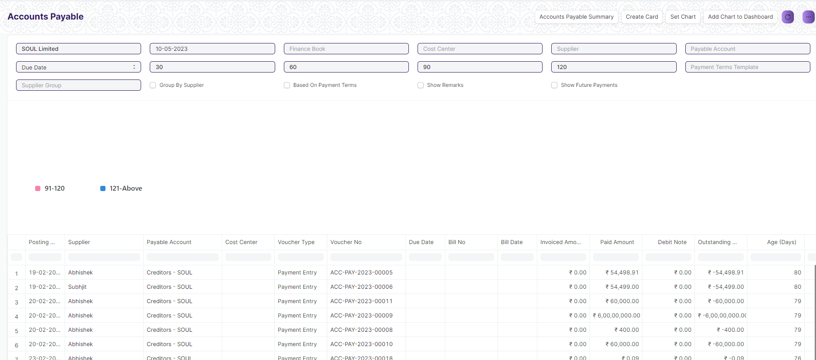

Figure: Accounts Payable Screen

**Input Filters**

|  |  |  |  |  |  |  |
| --- | --- | --- | --- | --- | --- | --- |
| **ID** | **Input Fields** | **Field Type** | **Mandatory** | **Validation/ Action** | **Remarks** | **R/N/D** |
| 1 | Company | Link Field |  |  | Default Company will be fetched |  |
| 2 | Posting Date | Date |  |  | Today’s date will be auto-fetched |  |
| 3 | Finance Book | Link Field |  |  |  |  |
| 4 | Cost Center | Link Field |  |  |  |  |
| 5 | Supplier | Link Field |  |  |  |  |
| 6 | Payable Account | Link Field |  |  |  |  |
| 7 | Ageing Based On | Dropdown |  |  | Options: Posting Date, Due Date, Supplier Invoice Date |  |
| 8 | Ageing Range 1 | Number |  |  |  |  |
| 9 | Ageing Range 2 | Number |  |  |  |  |
| 10 | Ageing Range 3 | Number |  |  |  |  |
| 11 | Ageing Range 4 | Number |  |  |  |  |
| 12 | Payment Terms Template | Link Field |  |  |  |  |
| 13 | Supplier Group | Link Field |  |  |  |  |
| 14 | Group By Supplier | Checkbox |  | If checked, the report will be show by grouping the suppliers |  |  |
| 15 | Based On Payment Terms | Checkbox |  | If checked, a column payment terms will appear |  |  |
| 16 | Show Remarks | Checkbox |  | If checked, a column with remarks of the transactions will be shown |  |  |
| 17 | Show Future Payments | Checkbox |  | If checked, future payments will be shown |  |  |

**Actions**

* User will enter the search fields such as Date, Supplier, Payable Account etc. as per requirement
* A user can add or remove the headers with the help of Add Column or Remove Column button.

**Report Fields**

|  |  |  |
| --- | --- | --- |
| **ID** | **Column Name** | **Description** |
| 1 | Posting Date | This displays the posting date of the transaction |
| 2 | Payable Account | This displays the payable account |
| 3 | Cost Center | This displays the cost centers linked to the transactions |
| 4 | Voucher Type | This shows the voucher type |
| 5 | Voucher No | This shows the voucher number |
| 6 | Due Date | This shows the due date for the transaction |
| 7 | Bill No | This displays the bill no associated with the transaction |
| 8 | Bill Date | This shows the bill date |
| 9 | Invoiced Amount | Invoiced Amount of the transaction is shown in this column |
| 10 | Paid Amount | Paid Amount of the transaction is shown in this column |
| 11 | Debit Note | Debit Note if any is shown here |
| 12 | Outstanding Amount | Amount which is outstanding is shown in this column |
| 13 | Age (Days) | Age of the transaction is shown here |
| 14 | 0-30 | The 0-30 days interval represents the outstanding payable balances that are due within the next 30 days. |
| 15 | 31-60 | The 31-60 days interval represents the outstanding payable balances that are due within the next 40 days. |
| 16 | 61-90 | The 61-90 days interval represents the outstanding payable balances that are due within the next 90 days. |
| 17 | 91-120 | The 91-120 days interval represents the outstanding payable balances that are due within the next 120 days. |
| 18 | Currency | Currency in which the transaction has occurred is show here |
| 19 | Supplier Group | Supplier Group of the transaction is shown here |

**User: Roles & Permission**

The following table describes the users and their roles and permissions for the screens :

|  |  |  |  |  |  |  |  |  |
| --- | --- | --- | --- | --- | --- | --- | --- | --- |
| **ID** | **Role** | **Read** | **Write** | **Create** | **Delete** | **Submit** | **Cancel** | **Amend** |
| 1 | Accountant Admin | Yes | Yes | NA | NA | NA | NA | NA |
| 2 | Account Manager | Yes | Yes | NA | NA | NA | NA | NA |
| 3 | Account User | Yes | Yes | NA | NA | NA | NA | NA |

### 4.2.2 Accounts Payable Summary Report

**General Description**

The following table describes overall information about this screen:

|  |  |
| --- | --- |
| Description | The accounts payable summary is a report that provides an overview of the money owed by the organization to its vendors or suppliers. |
| Navigation | Home > Accounts > Accounts Payable > Accounts Payable Summary |
| Pre-requisites | The system should have records in the following screen   1. Company 2. GL Entries 3. Payment Entries 4. Purchase Invoice |
| Existing Screen Name | Accounts Payable Summary |
| New Screen Name | No change |

**Screenshot**

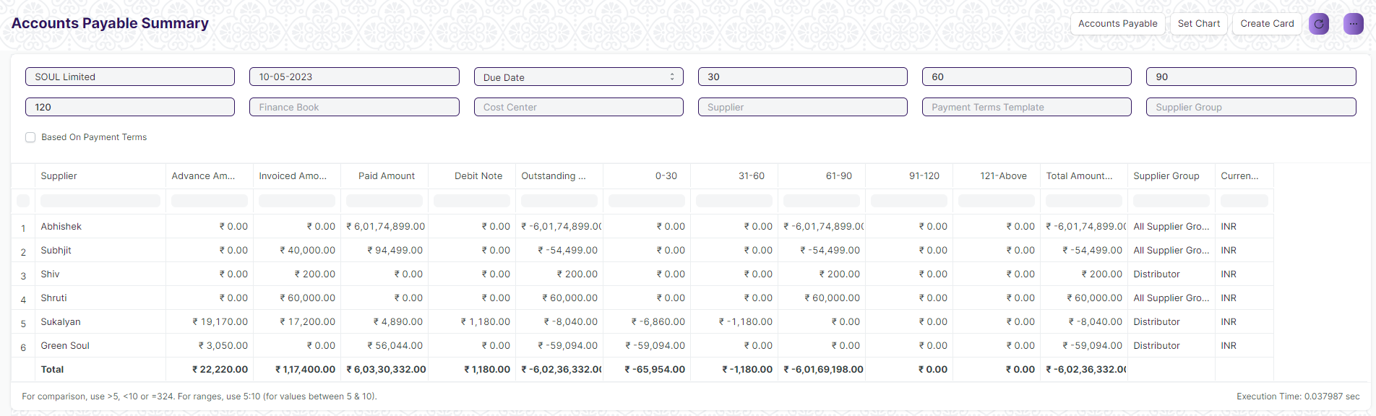

Figure: Accounts Payable Summary Screen

**Input Filters**

|  |  |  |  |  |  |  |
| --- | --- | --- | --- | --- | --- | --- |
| **ID** | **Input Fields** | **Field Type** | **Mandatory** | **Validation/ Action** | **Remarks** | **R/N/D** |
| 1 | Company | Link Field |  |  | Default Company will be fetched |  |
| 2 | Posting Date | Date |  |  | Today’s date will be auto-fetched |  |
| 3 | Ageing Based On | Dropdown |  |  | Options: Posting Date, Due Date, Supplier Invoice Date |  |
| 4 | Ageing Range 1 | Number |  | User Input |  |  |
| 5 | Ageing Range 2 | Number |  | User Input |  |  |
| 6 | Ageing Range 3 | Number |  | User Input |  |  |
| 7 | Ageing Range 4 | Number |  | User Input |  |  |
| 8 | Finance Book | Link Field |  |  |  |  |
| 9 | Cost Center | Link Field |  |  |  |  |
| 10 | Supplier | Link Field |  |  |  |  |
| 11 | Payment Terms Template | Link Field |  |  |  |  |
| 12 | Supplier Group | Link Field |  |  |  |  |
| 13 | Based On Payment Terms | Checkbox |  | If checked, a column payment terms will appear |  |  |

**Actions**

* User will enter the search fields such as Date, Supplier Group,Payment Terms Template etc. as per requirement
* A user can add or remove the headers with the help of Add Column or Remove Column button.

**Report Fields**

|  |  |  |
| --- | --- | --- |
| **ID** | **Column Name** | **Description** |
|  | Supplier | This displays the supplier name |
|  | Advance Amount | This displays the advance amount |
|  | Invoice Amount | This displays the invoice amount for the supplier |
|  | Paid Amount | This shows the paid amount |
|  | Debit Note | This shows the debit note if any |
|  | Outstanding Amount | This shows the outstanding amount for the transaction |
|  | 0-30 | The 0-30 days interval represents the outstanding payable balances that are due within the next 30 days. |
|  | 31-60 | The 31-41 days interval represents the outstanding payable balances that are due within the next 40 days. |
|  | 61-90 | The 61-90 days interval represents the outstanding payable balances that are due within the next 90 days. |
|  | 91-120 | The 91-120 days interval represents the outstanding payable balances that are due within the next 120 days. |
|  | 121-Above | This interval represents the outstanding payable balances that are due within the next 120 and above days. |
|  | Total Amount | This represents the amount summation link to each supplier |
|  | Supplier Group | Supplier Group of the transaction is shown here |
|  | Currency | Currency in which the transaction has occurred is show here |

**User: Roles & Permission**

The following table describes the users and their roles and permissions for the screens :

|  |  |  |  |  |  |  |  |  |
| --- | --- | --- | --- | --- | --- | --- | --- | --- |
| **ID** | **Role** | **Read** | **Write** | **Create** | **Delete** | **Submit** | **Cancel** | **Amend** |
| 1 | Accountant Admin | Yes | Yes | NA | NA | NA | NA | NA |
| 2 | Account Manager | Yes | Yes | NA | NA | NA | NA | NA |
| 3 | Account User | Yes | Yes | NA | NA | NA | NA | NA |

### Purchase Register Report

**General Description**

The following table describes overall information about this screen:

|  |  |
| --- | --- |
| **Description** | This reports help you to track the outstanding amount of Suppliers with respect to the unique invoice id. |
| **Navigation** | Home > Accounts > Account Payable > Purchase Register |
| **Pre-requisites** | The system should have records in the following screen   1. Company 2. Supplier 3. Cost Center |
| **Existing Screen Name** | Purchase Register |
| **New Screen Name** | No change |

**Screenshot**

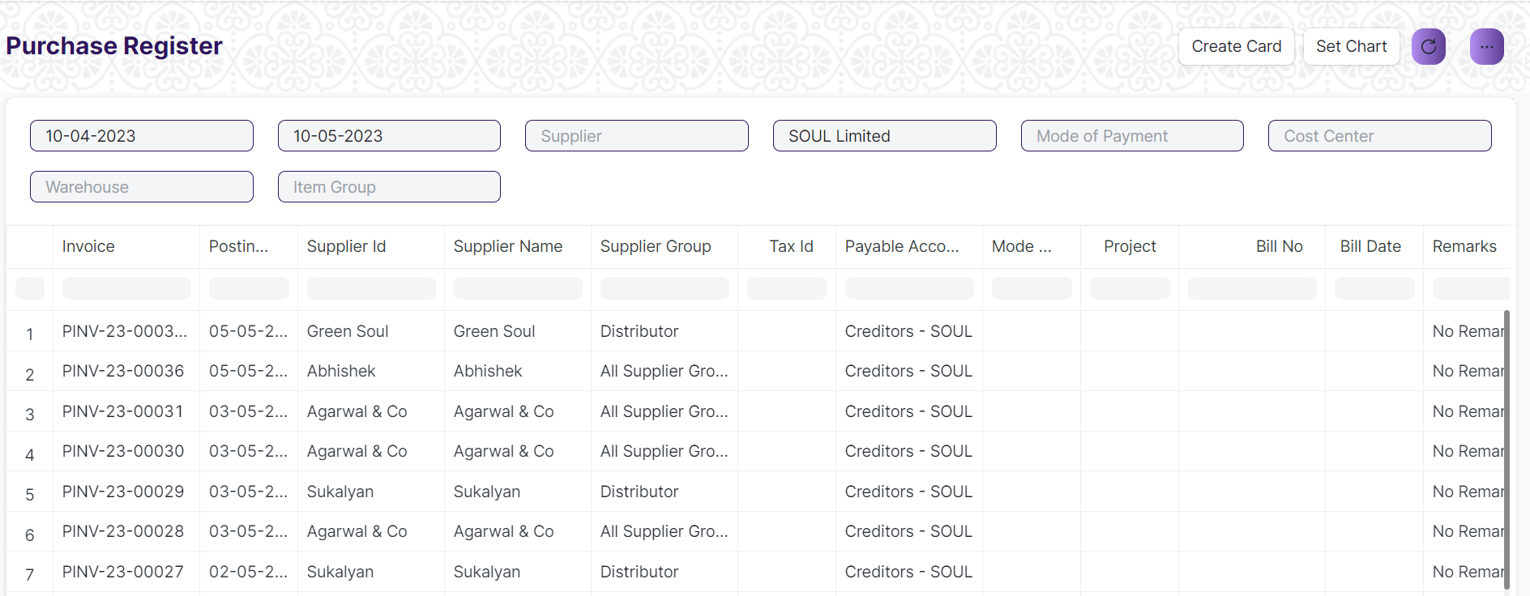

Figure: Purchase Register

**Input Filters**

|  |  |  |  |  |  |  |
| --- | --- | --- | --- | --- | --- | --- |
| **ID** | **Input Fields** | **Field Type** | **Mandatory** | **Validation/ Action** | **Remarks** | **R/N/D** |
|  | Company | Link Field |  |  |  |  |
|  | From Date | Date |  | From date should be before the To date |  |  |
|  | To Date | Date |  | To date should be after the from date |  |  |
|  | Mode of Payment | Link Field |  | Link Fields to Mode of Payment Screen |  |  |
|  | Cost Center | Link Field |  | Link Fields to Cost Center Screen |  |  |
|  | Supplier | Link Field |  | Link Fields to Supplier Screen |  |  |
|  | Warehouse | Link Field |  | Link Fields to Warehouse Screen |  |  |
|  | Item Group | Link Field |  | Link Fields to Item Group Screen |  |  |

**Actions**

* User will enter the search fields such as: Finance Book, Posting Date, etc. Based on that input, the report will be shown.
* A user can add or remove the headers with the help of Add Column or Remove Column button.

**Report Fields**

|  |  |  |
| --- | --- | --- |
| **ID** | **Column Name** | **Description** |
|  | Invoice | It will show the purchase invoice Id |
|  | Posting Date | It is the document posting date |
|  | Supplier Id | It is the Unique Id with respect to individual Suppliers |
|  | Supplier Name | It shows the supplier name with respect to the Supplier Id. |
|  | Supplier Group | It shows the Supplier group which divides different supplier based upon their individual details. It also contains the multiple company & accounts name. |
|  | Tax Id | It is the Unique Id for different type of Taxes. |
|  | Payable Account | It shows the Payable Accounts Name only. |
|  | Mode of Payment | Mode of Payment can be Cash, Online Payment, Cheque, etc. |
|  | Project | It will show the project name with respect to the supplier. |
|  | Bill No | Bill No generate with respect to the different item supplied by individual suppliers. |
|  | Bill Date | Date of Bill generate with respect to the different item supplied by individual suppliers. |
|  | Remarks | Remarks with respect to different invoice number will be shown. |
|  | Purchase Order | It show the purchase order id with respect to the head wise different supplier. |
|  | Purchase Receipt | It show the purchase receipt id with respect to the head wise different supplier. |
|  | Currency | It shows the currency such as INR, USD, etc. |
|  | Net Total | It shows the net total of different Items with respect to the received stock |
|  | Total Tax | It shows the total tax for different Items with respect to the received stock |
|  | Grand Total | It shows the Grand total amount created with respect to the different supplier |
|  | Outstanding Amount | It shows the Grand Outstanding amount created with respect to the different supplier. |

**User: Roles & Permission**

The following table describes the users and their roles and permissions for the screens :

|  |  |  |  |  |  |  |  |  |
| --- | --- | --- | --- | --- | --- | --- | --- | --- |
| **ID** | **Role** | **Read** | **Write** | **Create** | **Delete** | **Submit** | **Cancel** | **Amend** |
| 1 | Accountant Admin | Yes | Yes | NA | NA | NA | NA | NA |
| 2 | Account Manager | Yes | Yes | NA | NA | NA | NA | NA |
| 3 | Account User | Yes | Yes | NA | NA | NA | NA | NA |

### Item Wise Purchase Register Report

**General Description**

The following table describes overall information about this screen:

|  |  |
| --- | --- |
| **Description** | This reports help you to track the outstanding amount of Suppliers with respect to the individual Items. |
| **Navigation** | Home > Accounts > Account Payable > Item Wise Purchase Register |
| **Pre-requisites** | The system should have records in the following screen   1. Company 2. Supplier 3. Cost Center |
| **Existing Screen Name** | Item Wise Purchase Register |
| **New Screen Name** | No change |

**Screenshot**

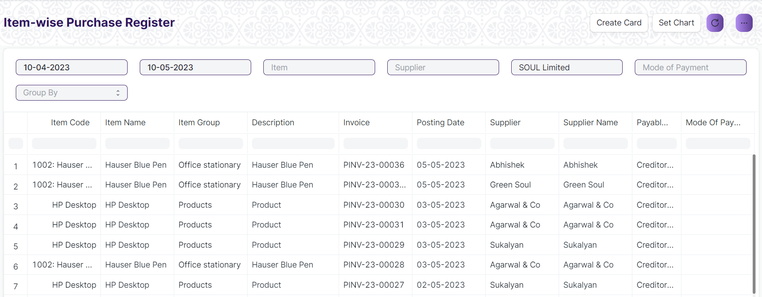Figure: Item Wise Purchase Register

**Input Filters**

|  |  |  |  |  |  |  |
| --- | --- | --- | --- | --- | --- | --- |
| **ID** | **Input Fields** | **Field Type** | **Mandatory** | **Validation/ Action** | **Remarks** | **R/N/D** |
|  | Company | Link Field |  | Link Field to Company Screen |  |  |
|  | From Date | Date |  | From date should be before the To date |  |  |
|  | To Date | Date |  | To date should be after the from date |  |  |
|  | Mode of Payment | Link Field |  | Link Fields to Mode of Payment Screen |  |  |
|  | Cost Center | Link Field |  | Link Fields to Cost Center Screen |  |  |
|  | Supplier | Link Field |  | Link Fields to Supplier Screen |  |  |
|  | Group By | Dropdown |  | Options :   1. Supplier 2. Item Group 3. Item 4. Invoice |  |  |
|  | Item | Link Field |  | Link Fields to Item Screen |  |  |

**Actions**

* User will enter the search fields such as: Item, Posting Date, etc. Based on that input, the report will be shown.
* A user can add or remove the headers with the help of Add Column or Remove Column button.

**Report Fields**

|  |  |  |
| --- | --- | --- |
| **ID** | **Column Name** | **Description** |
|  | Invoice | It will show the purchase invoice Id |
|  | Posting Date | It is the document posting date |
|  | Supplier Id | It is the Unique Id with respect to individual Suppliers |
|  | Supplier Name | It shows the supplier name with respect to the Supplier Id. |
|  | Payable Account | It shows the Payable Accounts Name only. |
|  | Mode of Payment | Mode of Payment can be Cash, Online Payment, Cheque, etc. |
|  | Project | It will show the project name with respect to the supplier. |
|  | Stock Qty | It shows the Supplier wise stock quantity |
|  | Stock UOM | It shows the Stock UOM such as in numbers, in Grams, in KG, in Faraday, etc. |
|  | Purchase Order | It show the purchase order id with respect to the head wise different supplier. |
|  | Purchase Receipt | It show the purchase receipt id with respect to the head wise different supplier. |
|  | Currency | It shows the currency such as INR, USD, etc. |
|  | Total Other Charger | It shows the total other charges of different Items with respect to the individual Supplier. |
|  | Total Tax | It shows the total tax for different Items with respect to the individual Supplier. |
|  | Rate | It shows the rate of an item |
|  | Amount | It shows the amount of an item |
|  | % of Grand Total | It shows the percentage of grand total amount of an item with respect to a particular Supplier |
|  | Company | It shows the Company name from where the supplier and the items belongs to. |

**User: Roles & Permission**

The following table describes the users and their roles and permissions for the screens :

|  |  |  |  |  |  |  |  |  |
| --- | --- | --- | --- | --- | --- | --- | --- | --- |
| **ID** | **Role** | **Read** | **Write** | **Create** | **Delete** | **Submit** | **Cancel** | **Amend** |
| 1 | Accountant Admin | Yes | Yes | NA | NA | NA | NA | NA |
| 2 | Account Manager | Yes | Yes | NA | NA | NA | NA | NA |
| 3 | Account User | Yes | Yes | NA | NA | NA | NA | NA |

### Trial Balance for Party Report

**General Description**

|  |  |
| --- | --- |
| **Description** | It is common to review the trial balance for employees, students, and suppliers. This information can be easily accessed for all individuals or for specific individuals. |
| **Navigation** | Home > Accounts > Reports > Trial Balance for Party |
| **Pre-requisites** | 1. Company 2. Account 3. Party Type 4. Party 5. Fiscal Year |
| **Existing Screen Name** | Trial Balance for Party |
| **New Screen Name** | Group Summary |

**Screenshot**

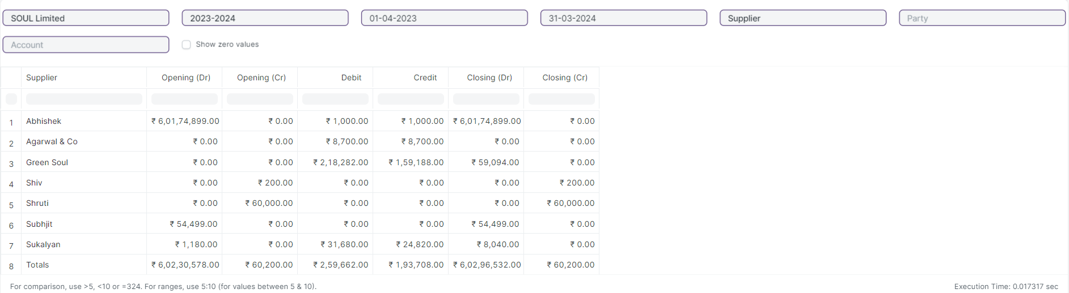

Figure: Trial Balance for Party Report

**Input Filters**

|  |  |  |  |  |  |  |
| --- | --- | --- | --- | --- | --- | --- |
| **ID** | **Field Label** | **Field Type** | **Validation/Action** | **Mandatory** | **Remarks** | **R/N/D** |
|  | Company | Link Field | Fetched from Company master screen |  |  |  |
|  | Fiscal Year | Link Field | Fetched from Fiscal Year master screen |  |  |  |
|  | From Date | Date | From Date should be less than To Date |  |  |  |
|  | To Date | Date | To Date should be greater than From Date |  |  |  |
|  | Party Type | Link Field | Fetched from Party Type master screen |  |  |  |
|  | Party | Link Field | Fetched from selected Party Type |  |  |  |
|  | Account | Link Field | Fetched from Account master screen |  |  |  |
|  | Show Zero Values | Check box |  |  | It display parties that have a zero balance in the report. |  |

**Actions**

* User will enter the search fields such as: Account, Voucher No, etc. Based on that input, the report will be shown.
* User can add or remove the headers with the help of Add Column or Remove Column button.

**Report Fields**

|  |  |  |
| --- | --- | --- |
| **ID** | **Column Fields** | **Description** |
|  | Party Type | Categorization of parties involved in transactions, such as Student, suppliers etc. |
|  | Opening (Dr) | Opening (Dr) represent the opening debit balances |
|  | Opening (Cr) | Opening (Cr) represent the opening credit balances |
|  | Debit | Debit represent the total debit transactions during the period |
|  | Credit | Credit represent the total credit transactions during the period |
|  | Closing (Dr) | Closing (Dr) represents the closing debit balance |
|  | Closing (Cr) | Closing (Cr) represents the closing credit balance |

**User: Roles & Permission**

The following table describes the users and their roles and permissions for the screens :

|  |  |  |  |  |  |  |  |  |
| --- | --- | --- | --- | --- | --- | --- | --- | --- |
| **ID** | **Role** | **Read** | **Write** | **Create** | **Delete** | **Submit** | **Cancel** | **Amend** |
|  | Account User | Yes | No | NA | NA | NA | NA | NA |
|  | Account Manager | Yes | No | NA | NA | NA | NA | NA |
|  | Account Admin | Yes | Yes | NA | NA | NA | NA | NA |

### 4.6 Tax Detail Report

**General Description**

|  |  |
| --- | --- |
| **Description** | Tax Details report provides an overview of all the taxes applied to transactions.This report shows the Item Tax Template, Taxes and Charges Template and Tax Category linked to various voucher types in the application. |
| **Navigation** | Home > Accounts > Reports > Tax Detail |
| **Pre-requisites** | Company  Fiscal Year  Account |
| **Existing Screen Name** | Tax Detail |
| **New Screen Name** | NA |

**Screenshot**

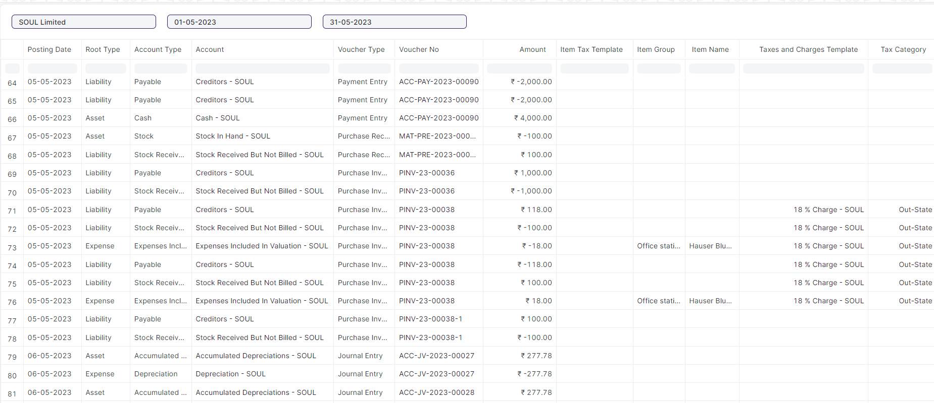

Figure: Tax Detail Report

**Input Filters**

|  |  |  |  |  |  |  |
| --- | --- | --- | --- | --- | --- | --- |
| **ID** | **Field Label** | **Field Type** | **Validation/Action** | **Mandatory** | **Remarks** | **R/N/D** |
|  | Company | Link Field | Fetched from Company master screen |  |  |  |
|  | From Date | Date | From Date should be less than To Date |  |  |  |
|  | To Date | Date | To Date should be greater than From Date |  |  |  |

**Actions**

* User will enter the search fields such as: Account, Voucher No, etc. Based on that input, the report will be shown.
* User can add or remove the headers with the help of Add Column or Remove Column button.

**Report Fields**

|  |  |  |
| --- | --- | --- |
| **ID** | **Column Fields** | **Description** |
|  | Posting Date | Date of the transaction |
|  | Root Type | Account Root types are mainly classified as income, expense, asset, or liability. |
|  | Account Type | Account type of that account. |
|  | Account | Name of the Account. |
|  | Voucher Type | Different Types of Vouchers like Purchase Receipt, Stock Entry, etc. |
|  | Voucher No | Voucher no. is based on the voucher type. |
|  | Amount | Voucher amount. |
|  | Item Tax Template | Item Tax Template is a predefined tax template applied to items. |
|  | Item Group | Item Group is a grouping of similar items. |
|  | Item Name | Item Name is the name of the item. |
|  | Taxes and Charges Template | Taxes and Charges Template is a predefined tax template applied to transactions. |
|  | Tax Category | Tax Category is a predefined tax category assigned to taxes. |

**User: Roles & Permission**

The following table describes the users and their roles and permissions for the screens :

|  |  |  |  |  |  |  |  |  |
| --- | --- | --- | --- | --- | --- | --- | --- | --- |
| **ID** | **Role** | **Read** | **Write** | **Create** | **Delete** | **Submit** | **Cancel** | **Amend** |
|  | Account User | Yes | No | NA | NA | NA | NA | NA |
|  | Account Manager | Yes | No | NA | NA | NA | NA | NA |
|  | Account Admin | Yes | Yes | NA | NA | NA | NA | NA |

### 4.7 Supplier Ledger Summary Report

**General Description**

The following table describes overall information about this screen:

|  |  |
| --- | --- |
| Description | This Shows the Ledger by Individual Supplier Wise |
| Navigation | Home > Accounts > General Ledger > Supplier Ledger Summary |
| Pre-requisites | The system should have records in the following screen   1. Company 2. Finance Book 3. Supplier Group 4. Payment Term Template (Optional) |
| Existing Screen Name | Supplier Ledger Summary |
| New Screen Name | No change |

**Screenshot**

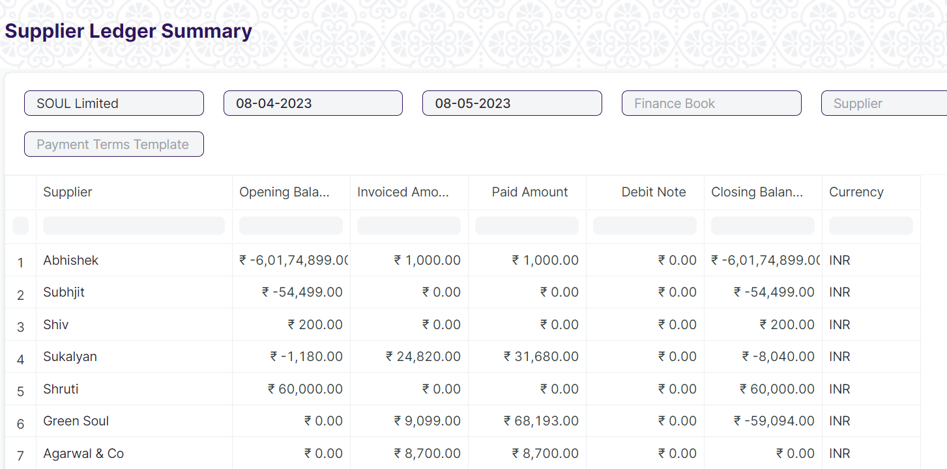

Figure: General Ledger Summary

**Input Filters**

|  |  |  |  |  |  |  |
| --- | --- | --- | --- | --- | --- | --- |
| **ID** | **Input Fields** | **Field Type** | **Mandatory** | **Validation/ Action** | **Remarks** | **R/N/D** |
|  | Company | Link Field |  | Link Field to the Company Screen |  |  |
|  | From Date | Date |  | From date should be before the To date |  |  |
|  | To Date | Date |  | To date should be after from date |  |  |
|  | Finance Book | Link Field |  | Link Fields to Finance Book Screen |  |  |
|  | Supplier | Link Field |  | Link Fields to Supplier Screen |  |  |
|  | Supplier Group | Link Field |  | Link Fields to Supplier Group Screen |  |  |
|  | Payment Terms Template | Link Field |  | Link Fields to Payment Terms Template Screen |  |  |

**Actions**

* User will enter the search fields such as: Finance Book, Supplier, No, etc. Based on that input, the report will be shown.
* A user can add or remove the headers with the help of Add Column or Remove Column button.

**Report Fields**

|  |  |  |
| --- | --- | --- |
| **ID** | **Column Name** | **Description** |
|  | Supplier | Suppliers are companies or individuals who provide you with products or services. |
|  | Opening Balance | Opening Balance of the Supplier. |
|  | Invoiced Amount | It shows the Invoiced amount of the supplier |
|  | Paid Amount | It shows the amount paid by the supplier. |
|  | Debit Note | It is a document send by a buyer to the supplier notifying that a debit has been recorded. |
|  | Closing Balance | It shows the closing balance of the supplier |
|  | Currency | It shows the currency such as INR, USD, etc. |

**User: Roles & Permission**

The following table describes the users and their roles and permissions for the screens :

|  |  |  |  |  |  |  |  |  |
| --- | --- | --- | --- | --- | --- | --- | --- | --- |
| **ID** | **Role** | **Read** | **Write** | **Create** | **Delete** | **Submit** | **Cancel** | **Amend** |
| 1 | Accountant Admin | Yes | Yes | NA | NA | NA | NA | NA |
| 2 | Account Manager | Yes | Yes | NA | NA | NA | NA | NA |
| 3 | Account User | Yes | Yes | NA | NA | NA | NA | NA |

## 5.Financial Statements

### 5.1 Trial Balance

**General Description**

|  |  |
| --- | --- |
| **Description** | A Trial Balance is an accounting report which lists account balances for all Accounts for any given reporting period. A company prepares a trial balance periodically, usually at the end of every reporting period. The general purpose of producing a trial balance is to ensure the entries in a company's bookkeeping system are mathematically correct. The totals of Debit and Credit columns must be same for any given period, to ensure the entries are correct. |
| **Navigation** | Home > Accounts > Financial Statements> Trial Balance |
| **Pre-requisites** | 1. Account 2. Company 3. Fiscal Year |
| **Existing Screen Name** | Trial Balance |
| **New Screen Name** | NA |

**Screenshot**

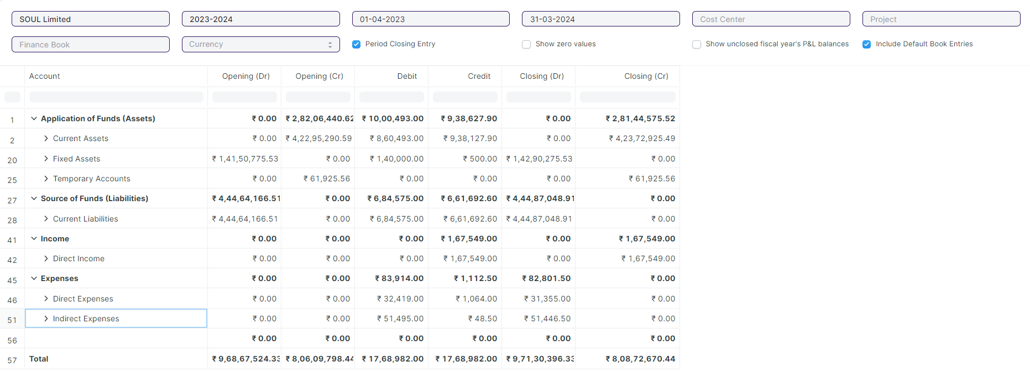

Figure: Trial Balance Report

**Input Filters**

|  |  |  |  |  |  |  |
| --- | --- | --- | --- | --- | --- | --- |
| **ID** | **Field Label** | **Field Type** | **Validation/Action** | **Mandatory** | **Remarks** | **R/N/D** |
|  | Company | Link Field | Fetched from Company master screen |  |  |  |
|  | Fiscal Year | Link Field | Fetched from Fiscal Year master screen |  |  |  |
|  | From Date | Date | From Date should be less than To Date |  |  |  |
|  | To Date | Date | To Date should be greater than From Date |  |  |  |
|  | Cost Center | Link Field | Fetched from Cost Center master screen |  |  |  |
|  | Project | Link Field | Fetched from Project master screen |  |  |  |
|  | Finance Book | Link Field | Fetched from Finance Book master screen |  |  |  |
|  | Currency | Link Field | Fetched from Currency master screen |  |  |  |
|  | Period Closing Entry | Checkbox |  |  | It shows the closing balances as per the period closing entries |  |
|  | Show Zero Values | Checkbox |  |  | It display parties that have a zero balance in the report. |  |
|  | Show unclosed fiscal year's P&L balances | Checkbox |  |  | It displays the profit and loss balances of unclosed fiscal years. |  |
|  | Include Default Book Entries | Checkbox |  |  | It includes predefined transactions used for opening balances of ledger accounts, such as banks, cash, and accounts payable/receivable. |  |

**Actions**

* User will enter the search fields such as: Account, Voucher No, etc. Based on that input, the report will be shown.
* User can add or remove the headers with the help of Add Column or Remove Column button.

**Report Fields**

|  |  |  |
| --- | --- | --- |
| **ID** | **Column Fields** | **Description** |
|  | Account | Account refers to the ledger accounts |
|  | Opening (Dr) | Opening (Dr) represent the opening debit balances |
|  | Opening (Cr) | Opening (Cr) represents the opening credit balances |
|  | Debit | Debit represents the total debit transactions during the period |
|  | Credit | Credit represents the total credit transactions during the period |
|  | Closing (Dr) | Closing (Dr) represents the closing debit balance |
|  | Closing (Cr) | Closing (Cr) represents the closing credit balance |

**User: Roles & Permission**

The following table describes the users and their roles and permissions for the screens :

|  |  |  |  |  |  |  |  |  |
| --- | --- | --- | --- | --- | --- | --- | --- | --- |
| **ID** | **Role** | **Read** | **Write** | **Create** | **Delete** | **Submit** | **Cancel** | **Amend** |
|  | Account User | Yes | No | NA | NA | NA | NA | NA |
|  | Account Manager | Yes | No | NA | NA | NA | NA | NA |
|  | Account Admin | Yes | Yes | NA | NA | NA | NA | NA |

### 5.2 Balance Sheet

**General Description**

|  |  |
| --- | --- |
| **Description** | A Balance Sheet is the financial statement of a company which states assets, liabilities and equity at a particular point in time.  The Balance Sheet gives more flexibility to analyse your financial position. You can run the report across multiple year to compare values. You can check values for a specific Finance Book or Cost Center. You can also choose any other currency to display the balances. |
| **Navigation** | Home > Accounts > Financial Statements> Balance Sheet |
| **Pre-requisites** | 1. Company 2. Fiscal Year 3. Account |
| **Existing Screen Name** | Balance Sheet |
| **New Screen Name** | NA |

**Screenshot**

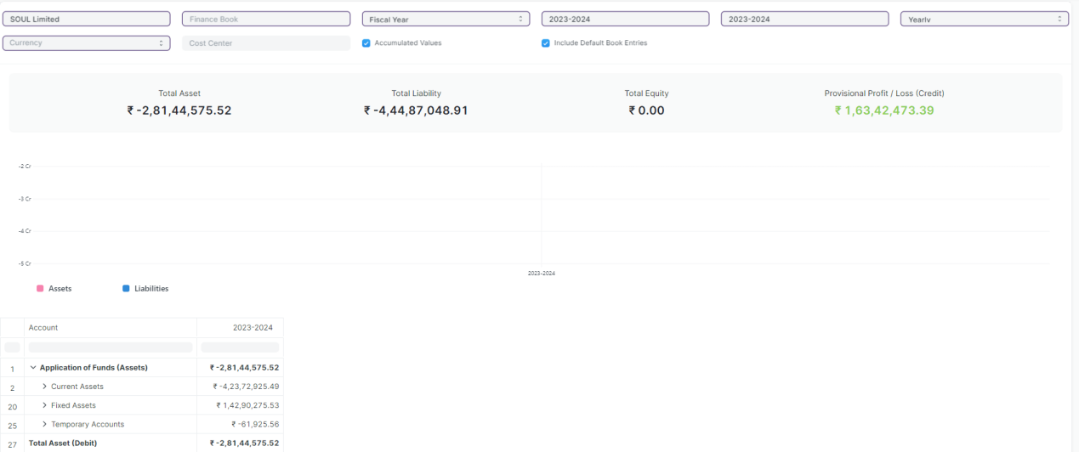

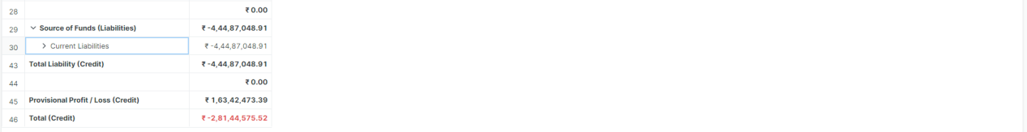

Figure: Balance Sheet Report

**Input Filters**

|  |  |  |  |  |  |  |
| --- | --- | --- | --- | --- | --- | --- |
| **ID** | **Field Label** | **Field Type** | **Validation/Action** | **Mandatory** | **Remarks** | **R/N/D** |
| 1. 1 | Company | Link Field | Fetched from Company master screen |  |  |  |
| 1. 2 | Finance Book | Link Field | Fetched from Finance Book master screen |  |  |  |
| 1. 3 | Filter Based On | Drop Down | Fiscal Year/Date Range |  |  |  |
| 1. 4 | Start Year | Link Field | Fetched from Fiscal Year master screen |  | Display depends on If Filter based on Fiscal Year |  |
| 1. 5 | End Year | Link Field | Fetched from Fiscal Year master screen |  | Display depends on If Filter based on Fiscal Year |  |
| 1. 6 | Start Date | Date | Start Date should be less than End Date |  | Display depends on If Filter based on Date Range |  |
| 1. 7 | End Date | Date | End Date should be greater than Start Date |  | Display depends on If Filter based on Date Range |  |
| 1. 8 | Periodicity | Dropdown | Monthly/Quarterly/Half-Yearly/Yearly |  |  |  |
| 1. 9 | Currency | Link Field | Fetched from Currency master screen |  |  |  |
| 1. 10 | Cost Center | Link Field | Fetched from Cost Center master screen |  |  |  |
| 1. 11 | Accumulated Values in Group Company | Checkbox |  |  |  |  |
| 1. 12 | Include Default Book Entries | Checkbox |  |  | It includes predefined transactions used for opening balances of ledger accounts, such as banks, cash, and accounts payable/receivable. |  |

**Actions**

* User will enter the search fields such as: Account, Voucher No, etc. Based on that input, the report will be shown.
* User can add or remove the headers with the help of Add Column or Remove Column button.

**Report Fields**

|  |  |  |
| --- | --- | --- |
| **ID** | **Column Fields** | **Description** |
|  | Account | Name of the Account |
|  | Amount | Amount based on the Amount |

**User: Roles & Permission**

The following table describes the users and their roles and permissions for the screens :

|  |  |  |  |  |  |  |  |  |
| --- | --- | --- | --- | --- | --- | --- | --- | --- |
| **ID** | **Role** | **Read** | **Write** | **Create** | **Delete** | **Submit** | **Cancel** | **Amend** |
|  | Account User | No | No | NA | NA | NA | NA | NA |
|  | Account Manager | No | No | NA | NA | NA | NA | NA |
|  | Account Admin | Yes | Yes | NA | NA | NA | NA | NA |

### 5.3 Profit and Loss Statement

**General Description**

|  |  |
| --- | --- |
| **Description** | A Profit and Loss Statement is a financial statement which summarizes all the revenues and expenses in a given period. The report is also known as P&L Statement.  You can run the report across multiple year / period to compare the values. You can also check values for a specific Finance Book, Project or Cost Center. You can also choose any other currency to display the balances. If you are running the report to see quarterly / monthly balances, you can choose whether you want to show accumulated balances or only for each period. |
| **Navigation** | Home > Accounts > Financial Statements> Profit and Loss Statement |
| **Pre-requisites** | 1. Company 2. Fiscal Year 3. Account |
| **Existing Screen Name** | Profit and Loss Statement |
| **New Screen Name** | NA |

**Screenshot**

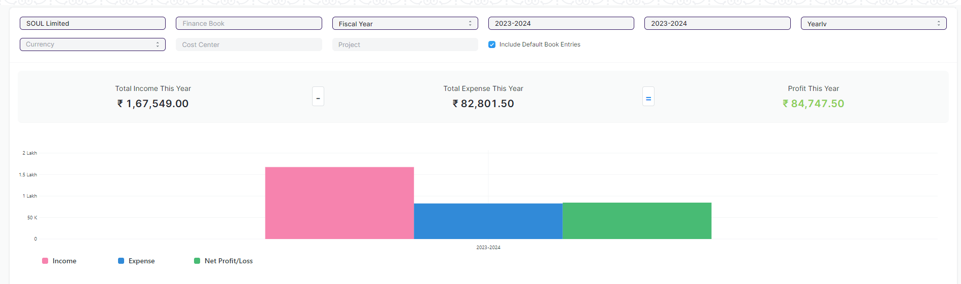

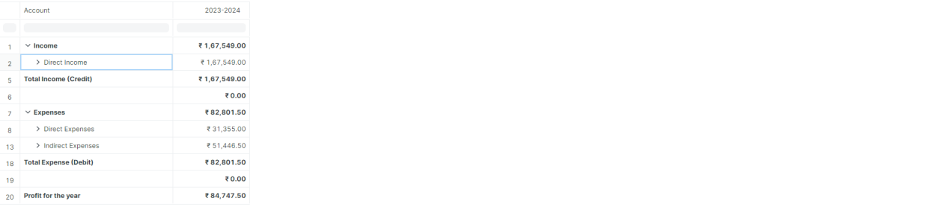

Figure: Profit and Loss Statement Report

**Input Filters**

|  |  |  |  |  |  |  |
| --- | --- | --- | --- | --- | --- | --- |
| **ID** | **Field Label** | **Field Type** | **Validation/Action** | **Mandatory** | **Remarks** | **R/N/D** |
|  | Company | Link Field | Fetched from Company master screen |  |  |  |
|  | Finance Book | Link Field | Fetched from Finance Book master screen |  |  |  |
|  | Filter Based On | Drop Down | Fiscal Year/Date Range |  |  |  |
|  | Start Year | Link Field | Fetched from Fiscal Year master screen |  | Display depends on If Filter based on Fiscal Year |  |
|  | End Year | Link Field | Fetched from Fiscal Year master screen |  | Display depends on If Filter based on Fiscal Year |  |
|  | Start Date | Date | Start Date should be less than End Date |  | Display depends on If Filter based on Date Range |  |
|  | End Date | Date | End Date should be greater than Start Date |  | Display depends on If Filter based on Date Range |  |
|  | Periodicity | Dropdown | Monthly/Quarterly/Half-Yearly/Yearly |  |  |  |
|  | Currency | Link Field | Fetched from Currency master screen |  |  |  |
|  | Cost Center | Link Field | Fetched from Cost Center master screen |  |  |  |
|  | Project | Link Field | Fetched from Project master screen |  |  |  |
|  | Include Default Book Entries |  |  |  | It includes predefined transactions used for opening balances of ledger accounts, such as banks, cash, and accounts payable/receivable. |  |

**Actions**

* User will enter the search fields such as: Account, Voucher No, etc. Based on that input, the report will be shown.
* User can add or remove the headers with the help of Add Column or Remove Column button.

**Report Fields**

|  |  |  |
| --- | --- | --- |
| **ID** | **Column Fields** | **Description** |
|  | Account | Name of the Account |
|  | Amount | Amount based on the Amount |

**User: Roles & Permission**

The following table describes the users and their roles and permissions for the screens :

|  |  |  |  |  |  |  |  |  |
| --- | --- | --- | --- | --- | --- | --- | --- | --- |
| **ID** | **Role** | **Read** | **Write** | **Create** | **Delete** | **Submit** | **Cancel** | **Amend** |
|  | Account User | No | No | NA | NA | NA | NA | NA |
|  | Account Manager | No | No | NA | NA | NA | NA | NA |
|  | Account Admin | Yes | Yes | NA | NA | NA | NA | NA |

### 5.4 Cash Flow

**General Description**

|  |  |
| --- | --- |
| **Description** | A Cash Flow is a financial statement which shows the incoming and outgoing of cash or cash-equivalents for a company. It is used to analyse the liquidity position of the company. |
| **Navigation** | Home > Accounts > Financial Statements> Cash Flow |
| **Pre-requisites** | 1. Company 2. Fiscal Year 3. Account |
| **Existing Screen Name** | Cash Flow |
| **New Screen Name** | NA |

**Screenshot**

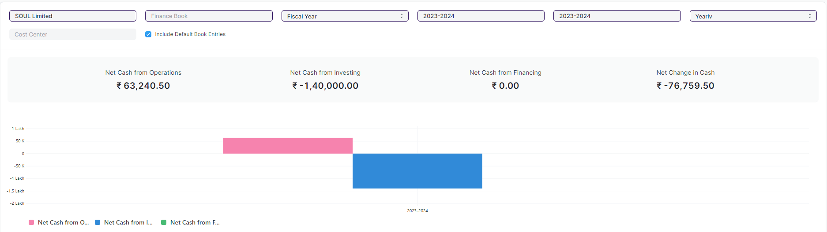

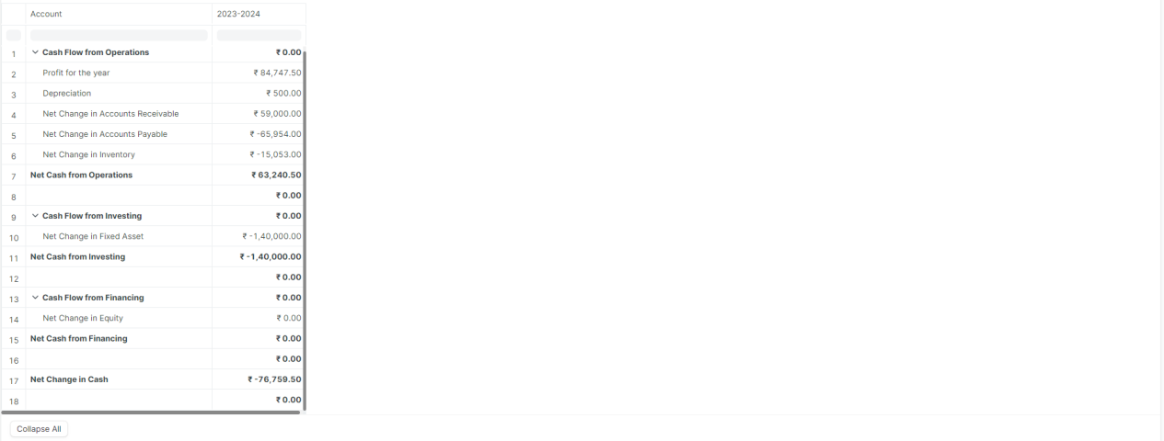

Figure: Cash Flow Report

**Input Filters**

|  |  |  |  |  |  |  |
| --- | --- | --- | --- | --- | --- | --- |
| **ID** | **Field Label** | **Field Type** | **Validation/Action** | **Mandatory** | **Remarks** | **R/N/D** |
| 1. 1 | Company | Link Field | Fetched from Company master screen |  |  |  |
| 1. 2 | Finance Book | Link Field | Fetched from Finance Book master screen |  |  |  |
| 1. 3 | Filter Based On | Drop Down | Fiscal Year/Date Range |  |  |  |
| 1. 4 | Start Year | Link Field | Fetched from Fiscal Year master screen |  | Display depends on If Filter based on Fiscal Year |  |
| 1. 5 | End Year | Link Field | Fetched from Fiscal Year master screen |  | Display depends on If Filter based on Fiscal Year |  |
| 1. 6 | Start Date | Date | Start Date should be less than End Date |  | Display depends on If Filter based on Date Range |  |
| 1. 7 | End Date | Date | End Date should be greater than Start Date |  | Display depends on If Filter based on Date Range |  |
| 1. 8 | Periodicity | Dropdown | Monthly/Quarterly/Half-Yearly/Yearly |  |  |  |
| 1. 9 | Cost Center | Link Field | Fetched from Cost Center master screen |  |  |  |
| 1. 10 | Include Default Book Entries | Checkbox |  |  | It includes predefined transactions used for opening balances of ledger accounts, such as banks, cash, and accounts payable/receivable. |  |

**Actions**

* User will enter the search fields such as: Account, Voucher No, etc. Based on that input, the report will be shown.
* User can add or remove the headers with the help of Add Column or Remove Column button.

**Report Fields**

|  |  |  |
| --- | --- | --- |
| **ID** | **Column Fields** | **Description** |
|  | Account | Name of the Account |
|  | Amount | Amount based on the Amount |

**User: Roles & Permission**

The following table describes the users and their roles and permissions for the screens :

|  |  |  |  |  |  |  |  |  |
| --- | --- | --- | --- | --- | --- | --- | --- | --- |
| **ID** | **Role** | **Read** | **Write** | **Create** | **Delete** | **Submit** | **Cancel** | **Amend** |
|  | Account User | Yes | No | NA | NA | NA | NA | NA |
|  | Account Manager | Yes | No | NA | NA | NA | NA | NA |
|  | Account Admin | Yes | Yes | NA | NA | NA | NA | NA |

### 5.5 Consolidated Financial Statement

**General Description**

|  |  |
| --- | --- |
| **Description** | The report shows a consolidated view of Balance Sheet, Profit and Loss Statement and Cash Flow for a group company, by merging financial statements of all the subsidary companies. It shows balances for all individual company and as well as accumulated balances for a group company. |
| **Navigation** | Home > Accounts > Financial Statements> Consolidated Financial Statement |
| **Pre-requisites** | 1. Company 2. Fiscal Year 3. Account |
| **Existing Screen Name** | Cash Flow |
| **New Screen Name** | NA |

**Screenshot**

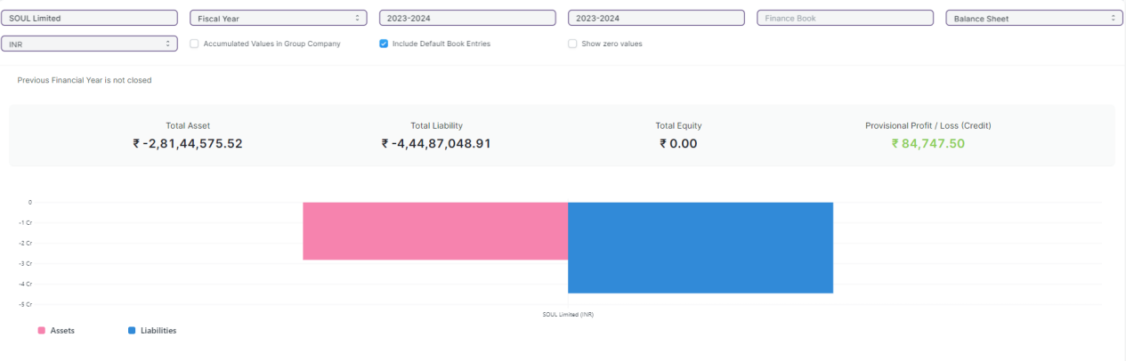

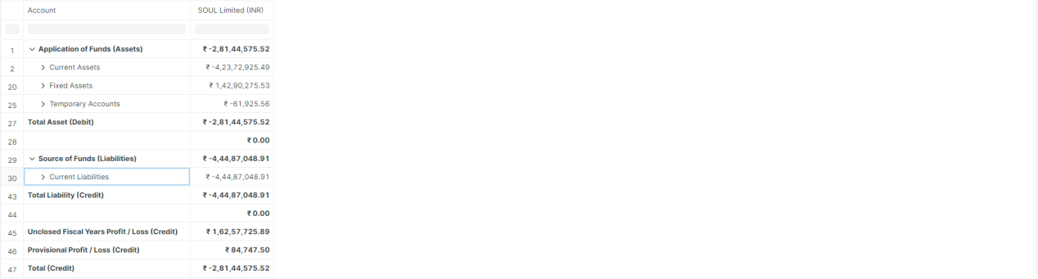

Figure: Consolidated Financial Statement Report

**Input Filters**

|  |  |  |  |  |  |  |
| --- | --- | --- | --- | --- | --- | --- |
| **ID** | **Field Label** | **Field Type** | **Validation/Action** | **Mandatory** | **Remarks** | **R/N/D** |
|  | Company | Link Field | Fetched from Company master screen |  |  |  |
|  | Filter Based On | Drop Down | Fiscal Year/Date Range |  |  |  |
|  | Start Year | Link Field | Fetched from Fiscal Year master screen |  | Display depends on If Filter based on Fiscal Year |  |
|  | End Year | Link Field | Fetched from Fiscal Year master screen |  | Display depends on If Filter based on Fiscal Year |  |
|  | Start Date | Date | Start Date should be less than End Date |  | Display depends on If Filter based on Date Range |  |
|  | End Date | Date | End Date should be greater than Start Date |  | Display depends on If Filter based on Date Range |  |
|  | Finance Book | Link Field | Fetched from Finance Book master screen |  |  |  |
|  | Report | Dropdown | Profit and Loss Statement/Balance Sheet/Cash Flow |  |  |  |
|  | Currency | Link Field | Fetched from Currency master screen |  |  |  |
|  | Accumulated Values in Group Company | Checkbox |  |  |  |  |
|  | Include Default Book Entries | Checkbox |  |  | It includes predefined transactions used for opening balances of ledger accounts, such as banks, cash, and accounts payable/receivable. |  |
|  | Show zero values | Checkbox |  |  | "Show Zero Values" option allows you to display parties that have a zero balance in the report. |  |

**Actions**

* User will enter the search fields such as: Account, Voucher No, etc. Based on that input, the report will be shown.
* User can add or remove the headers with the help of Add Column or Remove Column button.

**Report Fields**

|  |  |  |
| --- | --- | --- |
| **ID** | **Column Fields** | **Description** |
|  | Account | Name of the Account |
|  | Amount | Amount based on the Account |

**User: Roles & Permission**

The following table describes the users and their roles and permissions for the screens :

|  |  |  |  |  |  |  |  |  |
| --- | --- | --- | --- | --- | --- | --- | --- | --- |
| **ID** | **Role** | **Read** | **Write** | **Create** | **Delete** | **Submit** | **Cancel** | **Amend** |
|  | Account User | No | No | NA | NA | NA | NA | NA |
|  | Account Manager | No | No | NA | NA | NA | NA | NA |
|  | Account Admin | Yes | Yes | NA | NA | NA | NA | NA |

## 6. Fixed Deposit

**General Description:**

The following table describe overall information about this screen

|  |  |
| --- | --- |
| **Description :** | A fixed deposit (FD) is a [financial instrument](https://en.wikipedia.org/wiki/Financial_instrument" \o "Financial instrument) provided by banks or [non-bank financial institutions](https://en.wikipedia.org/wiki/Non-bank_financial_institution" \o "Non-bank financial institution) which provides investors a higher rate of [interest](https://en.wikipedia.org/wiki/Interest" \o "Interest) than a regular [savings account](https://en.wikipedia.org/wiki/Savings_account" \o "Savings account), until the given maturity date. It may or may not require the creation of a separate account.  This screen will help in tracking Fixed Deposits. |
| **Navigation :** | Home > Accounts > Fixed Deposit |
| **Pre-requisites :** | The system should have records in the following screen   1. Company 2. Account |
| **Existing Screen Name** | Fixed Deposit |
| **New Screen Name** | No change |

**Screenshots:**

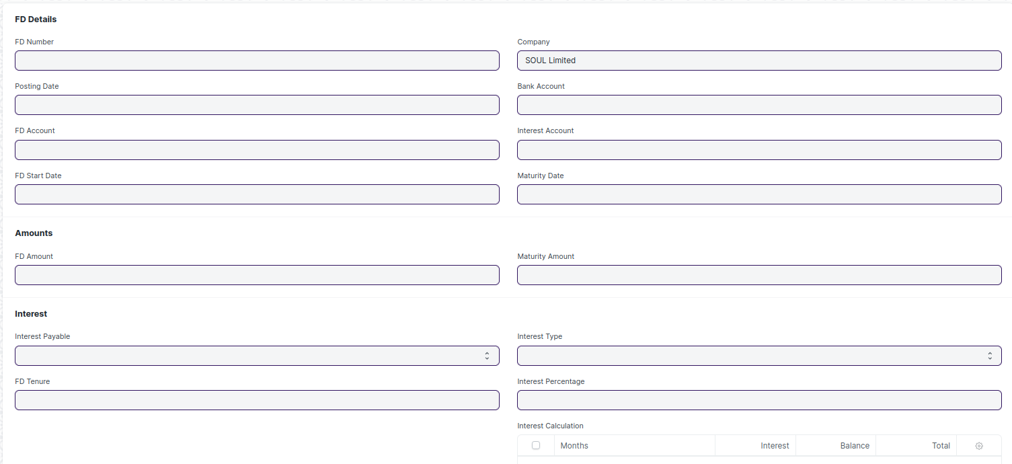

Figure: Fixed Deposit

**Field List:**

The following table describes the UI fields present in this screen:

|  |  |  |  |  |  |  |
| --- | --- | --- | --- | --- | --- | --- |
| **ID** | **Field Name** | **Field Type** | **Mandatory** | **Validation/Action** | **Remarks** | **R/N/D** |
| 1 | FD Number | Int |  |  |  |  |
| 2 | Posting Date | Date |  |  |  |  |
| 3 | FD Account | Link Field |  | Links to Account Screen |  |  |
| 4 | FD Start Date | Date |  | FD Start Date should be less than Maturity Date |  |  |
| 5 | Company | Link Field |  | Links to Company Screen |  |  |
| 6 | Bank Account | Link Field |  | Links to Account Screen |  |  |
| 7 | Interest Account | Link Field |  | Links to Account Screen |  |  |
| 8 | Maturity Date | Date |  | FD Maturity Date should be greater than FD Start Date |  |  |
| 9 | FD Amount | Currency |  |  |  |  |
| 10 | Maturity Amount | Currency |  |  |  |  |
| 11 | Interest Payable | Select |  | Options: On Maturity Quarterly Monthly |  |  |
| 12 | FD Tenure | Data |  |  |  |  |
| 13 | Interest Type | Select |  | Options: Simple Compound |  |  |
| 14 | Interest Percentage | Float |  |  |  |  |
| 15 | Interest Calculation | Table |  | Fixed Deposit Interest | For further details regarding table Please check below |  |

|  |  |  |  |  |  |  |
| --- | --- | --- | --- | --- | --- | --- |
| **Fixed Deposit Interest** | | | | | | |
| **ID** | **Field Name** | **Field Type** | **Validation/Action** | **Mandatory** | **Remarks** | **R/N/D** |
| 1 | Months | Data |  |  |  |  |
| 2 | Balance | Currency |  |  |  |  |
| 3 | Interest | Float |  |  |  |  |
| 4 | Total | Currency |  |  |  |  |

*Note: The above table is a sample for interest calculation. The fields and logic might change as it will be implemented at the later stage of the project.*

**User: Roles & Permission**

The following table describes the users and their roles and permissions for the screens :

|  |  |  |  |  |  |  |  |  |
| --- | --- | --- | --- | --- | --- | --- | --- | --- |
| **ID** | **Role** | **Read** | **Write** | **Create** | **Delete** | **Submit** | **Cancel** | **Amend** |
| 1 | Account User | Yes | Yes | Yes | No | NA | NA | NA |
| 2 | Account Manager | Yes | Yes | Yes | No | NA | NA | NA |
| 3 | Accountant Admin | Yes | Yes | Yes | No | NA | NA | NA |